Making Hard Time Harder
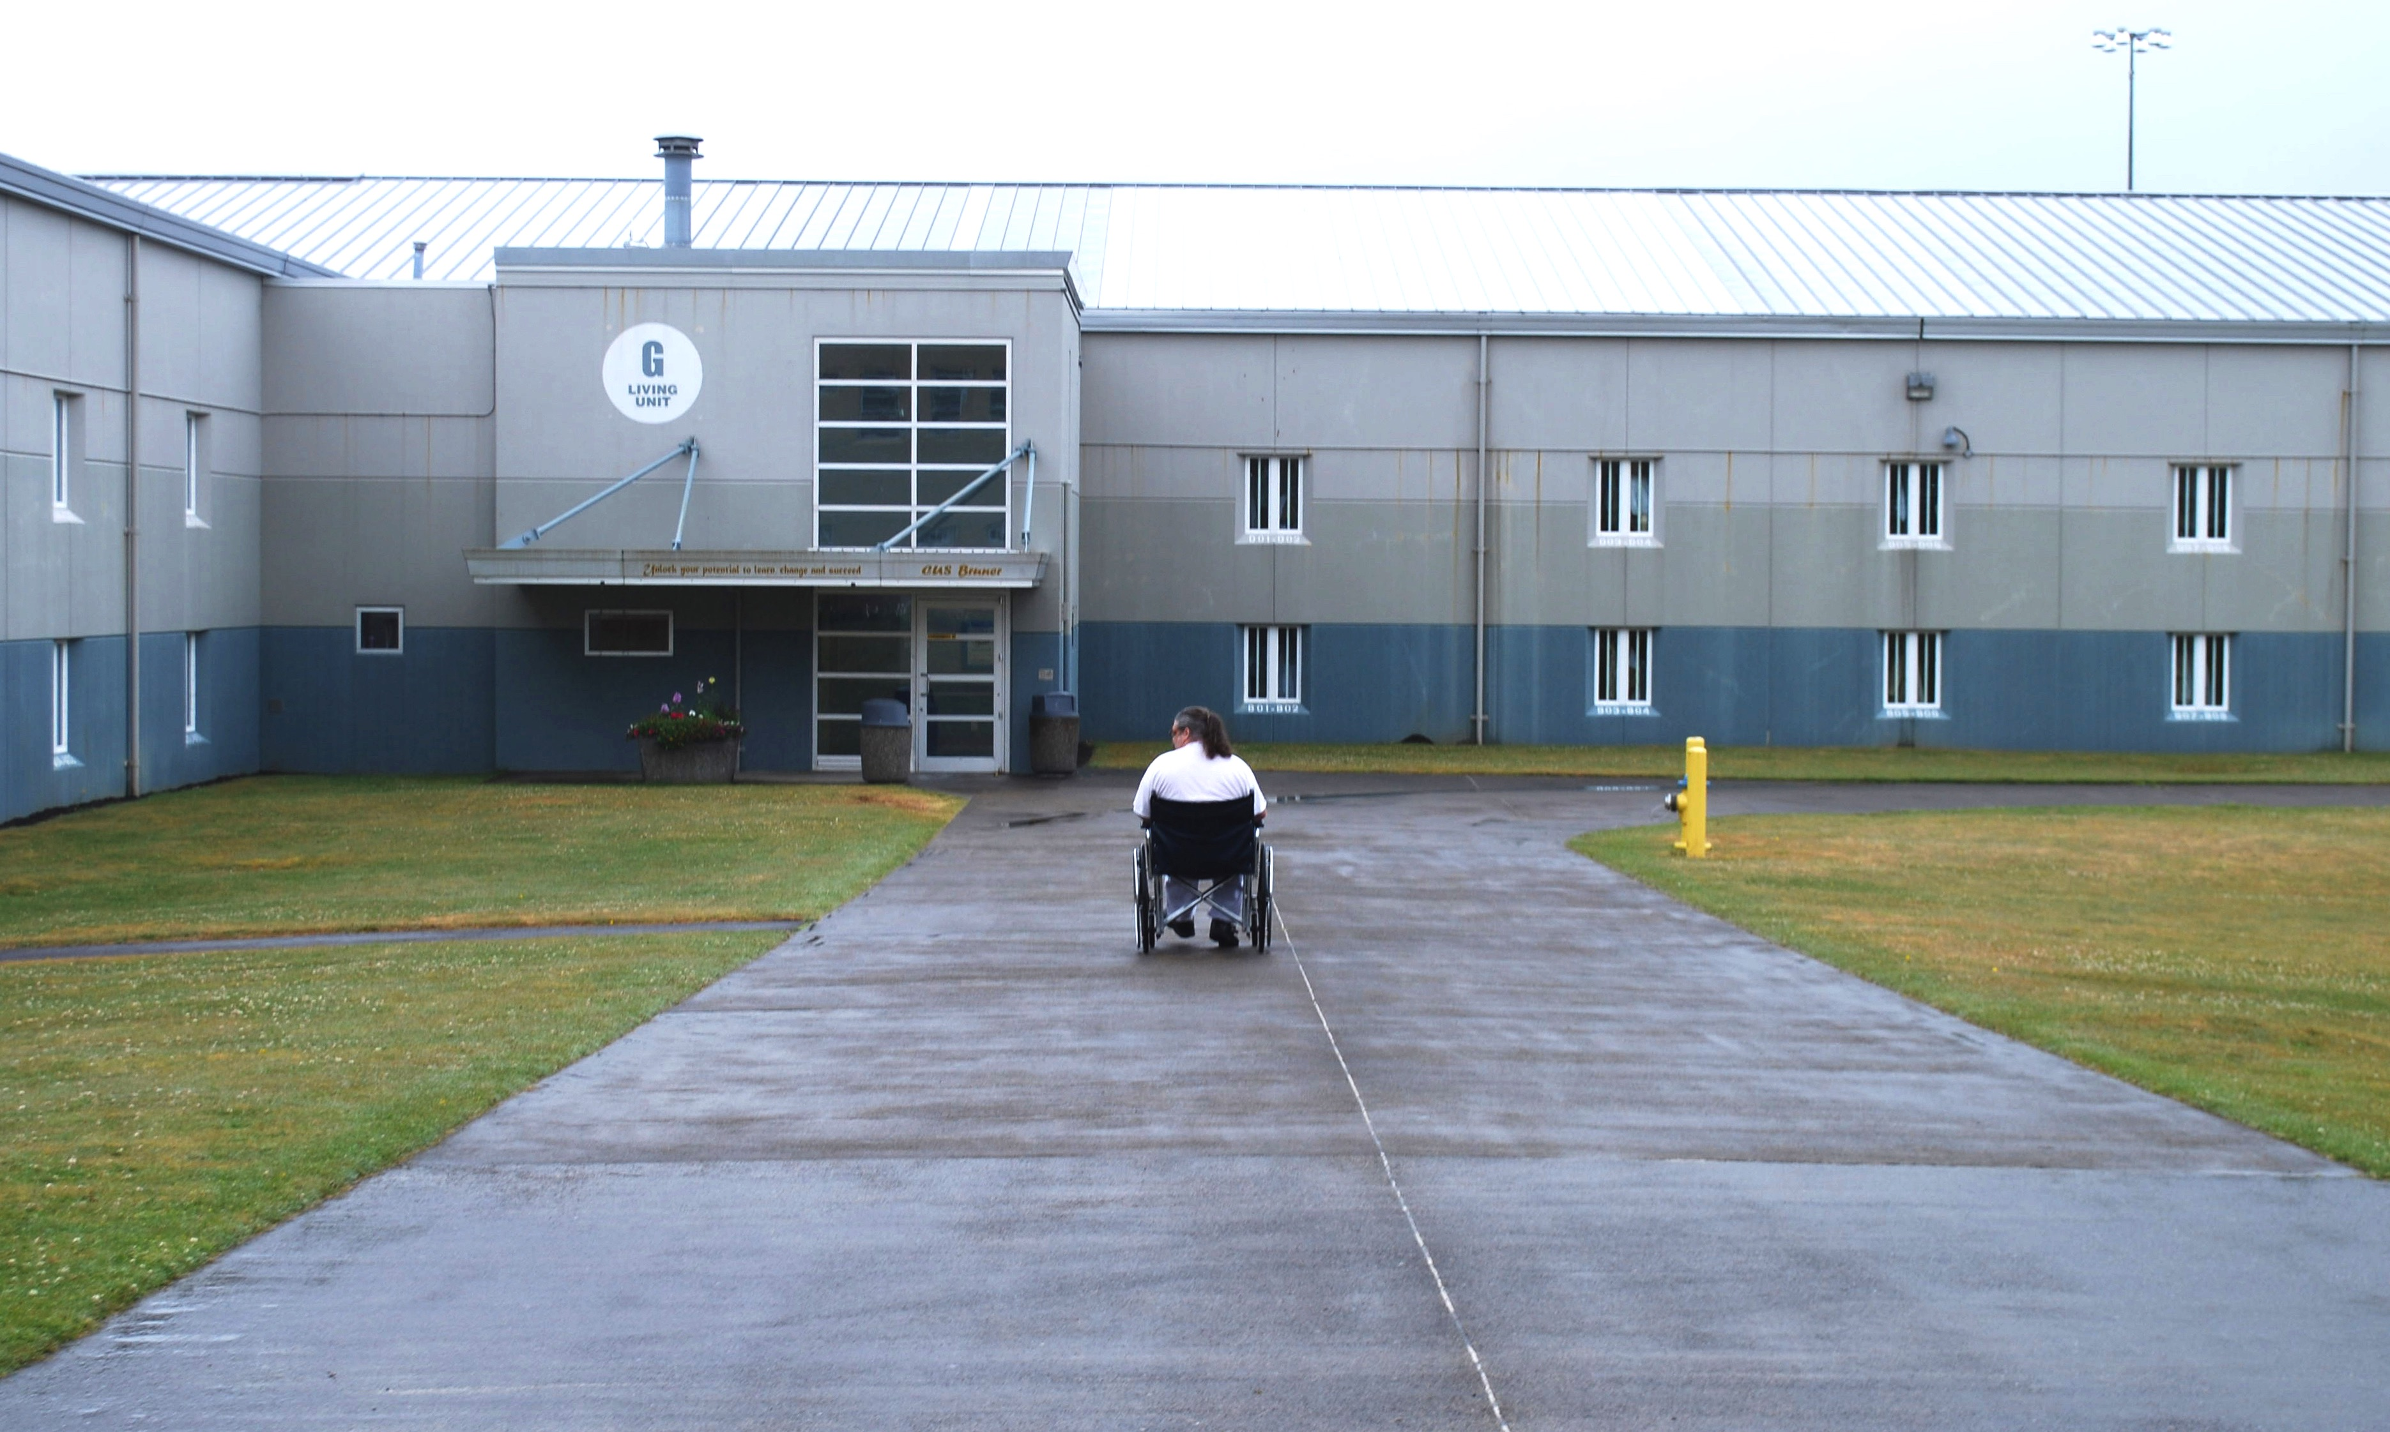
Programmatic Accommodations for Inmates with Disabilities Under the Americans with Disabilities Act

ABOUT THE PROJECT
The AVID Prison Project produced this report through a collaboration between The Arizona Center for Disability Law, Disability Law Colorado, The Advocacy Center of Louisiana, Disability Rights New York, Protection and Advocacy for People with Disabilities of South Carolina, Disability Rights Texas, Disability Rights Washington, The National Disability Rights Network, with contributions from other protection and advocacy agencies.

ABOUT THE AUTHOR
Rachael Seevers is an attorney with Disability Rights Washington’s AVID Prison Project, where she focuses on both individual and systemic advocacy on behalf of inmates with disabilities. Prior to coming to DRW, Rachael worked as an attorney in New York, focusing on appellate advocacy and civil rights litigation relating to the provision of care for people with mental illness. In New York, Rachael also worked as an adjunct professor at Cardozo Law School, teaching legal writing and lawyering skills to first year law students. Rachael graduated cum laude from Brooklyn Law School in 2006, where she was an Edward J. Sparer Public Interest Fellow.

This report, the multimedia report and associated videos,
designed and produced by Rooted in Rights.
Learn more at rootedinrights.org.

Published June 22, 2016
© 2016 Disability Rights Washington
TABLE OF CONTENTS

I. EXECUTIVE SUMMARY 4
II. BACKGROUND 8
A. Overview of the P&A System 8
B. Methods of P&A Advocacy 9
1. Individual Advocacy Within the Prison 9
2. Systemic Advocacy with Corrections Officials 9
3. Administrative Advocacy and Litigation 10
C. The ADA and Prisons 10
III. PRISON ADVOCACY BY THE PROTECTION AND ADVOCACY SYSTEM 13
A. Hygiene, Health, and Safety 13
1. Individual Advocacy Within the Prison 13
2. Systemic Advocacy with Corrections Officials 19
3. Administrative Advocacy and Litigation 19
B. Accommodations in Communication 21
1. Individual Advocacy Within the Prison 21
2. Systemic Advocacy with Corrections Officials 23
3. Administrative Advocacy and Litigation 24
C. Access to Programming and Services 27
1. Individual Advocacy Within the Prison 27
2. Systemic Advocacy with Corrections Officials 31
3. Administrative Advocacy and Litigation 34
IV. CONCLUSION 36
V. RECOMMENDATIONS 37
A. National Recommendations 37
B. State Recommendations 38

Please visit
AVIDprisonproject.org
for a multimedia version of this report
featuring videos of inmate interviews and more.

I. EXECUTIVE SUMMARY

The disproportionate incarceration of people with disabilities in the United States is a serious and growing problem. As the prison population ages, more inmates are reporting physical disabilities. The U.S. has also seen a rise in the number of people with mental illness and developmental and cognitive disabilities in prison. National surveys now indicate that as many as 31 percent of inmates in state prisons report having at least one disability.
There are
1,561,500
prison inmates
in the United States.

31%
are persons with a disability.

While prison is hard for everyone, incarceration is even more challenging for inmates with disabilities. Research shows that inmates with disabilities are sentenced to an average of fifteen more months in prison as compared to other inmates with similar criminal convictions. The time they serve is also harder, with more sanctions imposed and less access to positive programming than other inmates. Prisoners with disabilities are also four times more likely to report recent psychological distress as compared to inmates without disabilities. In a system intended to control and sanction behavior believed to violate the many regulations that govern prison life, inmates with disabilities who need accommodations are often overlooked, ignored, or even punished.

Very few outsiders are allowed into the prisons, and the public rarely gets to witness the conditions in which many inmates are confined. In recent years, protection and advocacy agencies (P&As), organizations granted with special federal authority to enter facilities that serve people with disabilities, have been going behind prison walls to identify issues facing inmates with disabilities.

P&As have received reports of inmates forced to drag themselves across their cell or sleep on the floor because their cane or walker was removed. Inmates with cognitive disorders, intellectual disabilities, or mental illness have sought assistance because they are unable to complete the programming required to move out of restrictive housing, forcing them to remain in segregation for years, if not decades. These same inmates may be punished for failing to follow the written rules of the prison, rules they either cannot read or cannot understand due to a disability, resulting in sanctions, loss of good time, or even additional criminal charges. Inmates in need of therapeutic diets or those who require assistance in activities of daily living often find themselves caught in an endless cycle of institutional grievances and appeals as they seek approval for accommodations in correctional policy and practice.

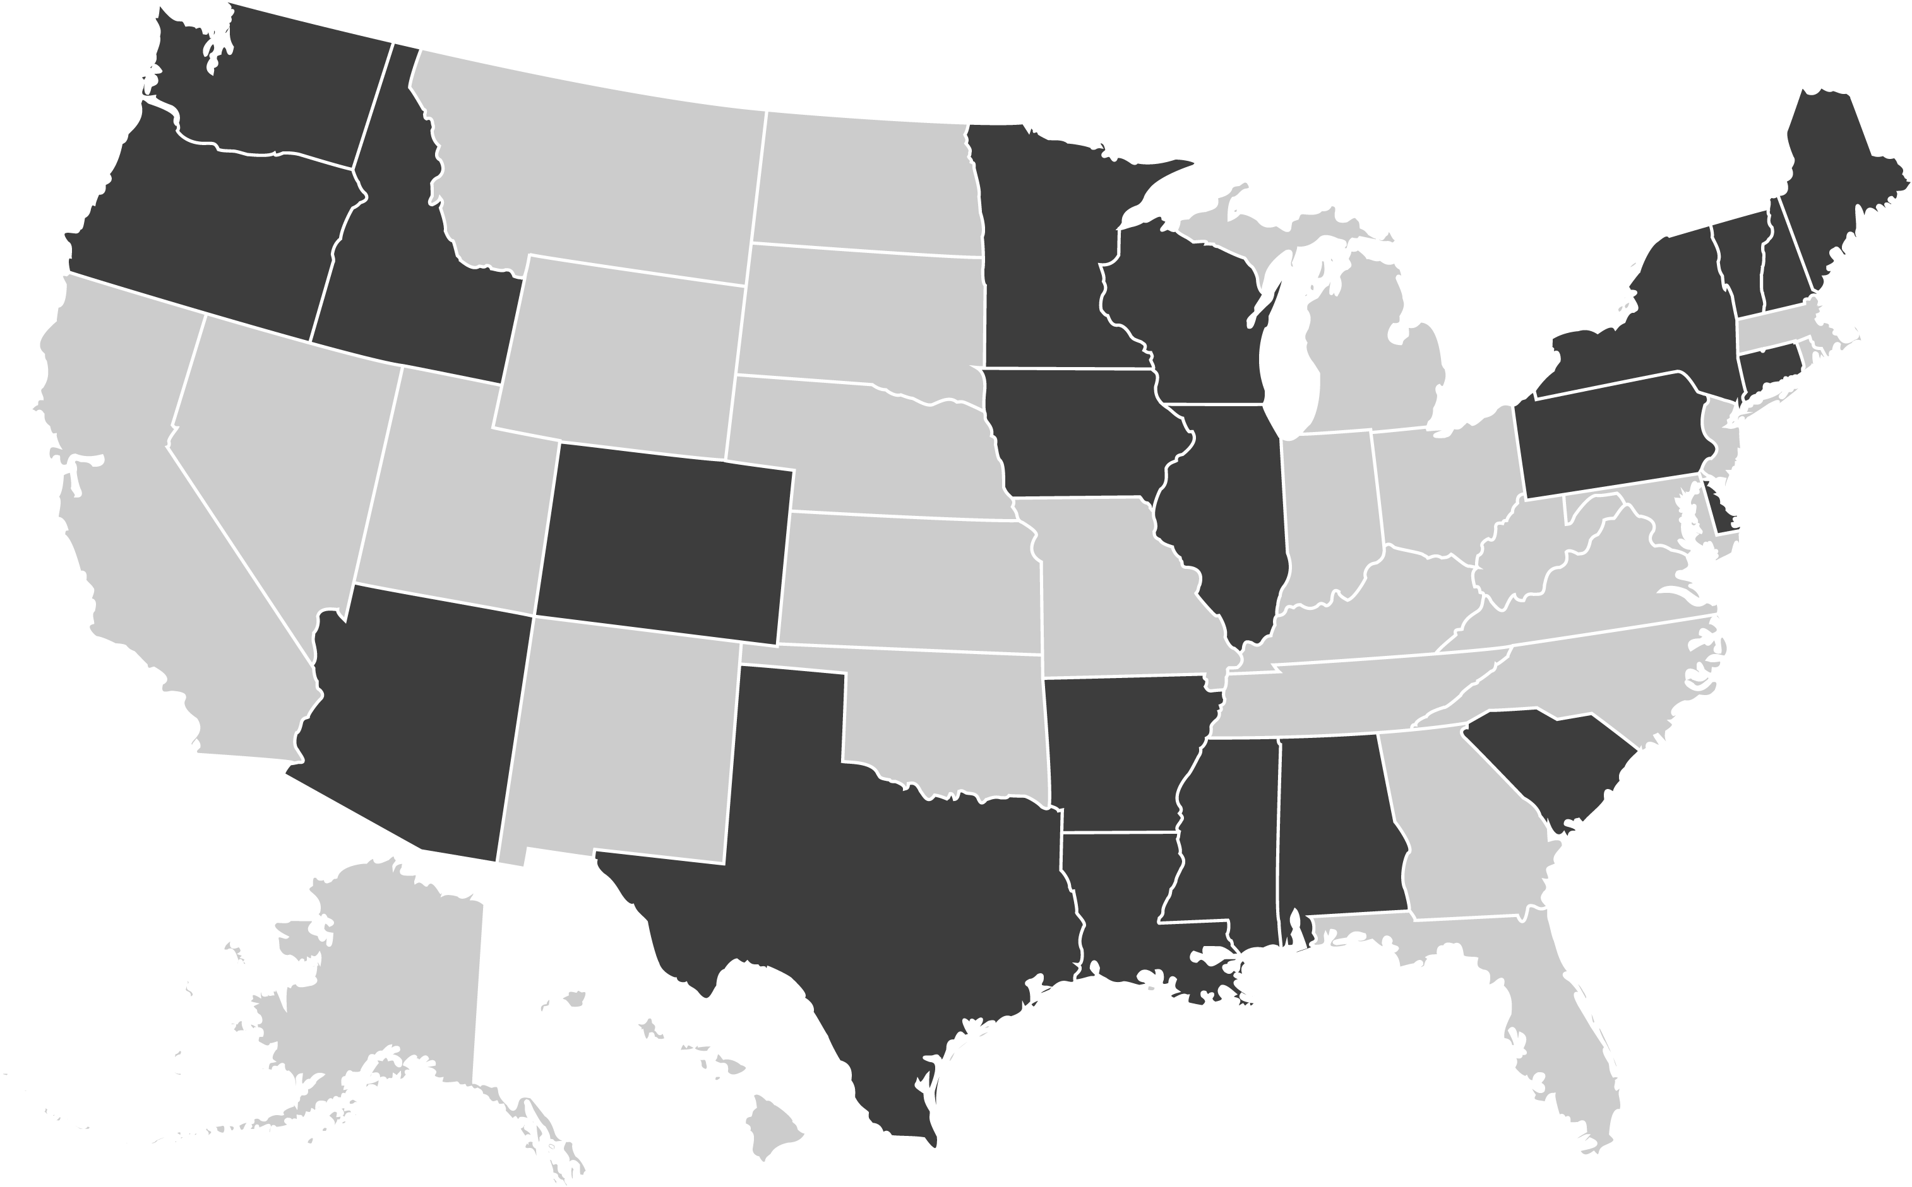
In recognition of the growing population of inmates with disabilities, in 2012 Disability Rights Washington, the P&A for Washington State, began focusing more attention on the state’s prisons, investigating the conditions of these correctional settings and working on creative solutions to some of the most serious problems faced by inmates with mental illness, brain injuries, and physical and intellectual disabilities. In early 2014, with increased funding through a private grant, Disability Rights Washington created Amplifying Voices of Inmates with Disabilities (AVID), a project with the sole purpose of protecting and advancing the rights of inmates with disabilities and assisting those who are reentering society. In September 2014, AVID brought together staff from the P&As in New York, South Carolina, Arizona, Colorado, Louisiana, and Texas, as well as from the National Disability Rights Network, to strategize about ways to increase national attention on the issues faced by inmates with disabilities.
Figure 1. Image of the United States with contributing state P&A highlighted in black.

This report, which has grown out of that collaborative national effort, aims to highlight the difficulties that inmates with disabilities face as they seek to access programs and services in state prison systems. P&As from across the country provided examples of either past or ongoing advocacy to enforce the protections of the Americans with Disabilities Act (ADA) on behalf of inmates with disabilities. By no means exhaustive, this report provides an overview of the protections afforded to inmates with disabilities under the ADA as well as examples in which P&As have advocated effectively on behalf of inmates with disabilities. This advocacy is multi-modal, ranging from routine monitoring, to informal and individual advocacy, to systemic litigation.

This report begins with a brief overview of the P&A system, describes the different types of advocacy P&As use, and outlines the ADA’s application to prisons. Next, this report details the work P&As across the country have done to advance inmates’ rights under the ADA, focusing on three main areas of prison life: (1) hygiene, health, and safety, (2) accommodations in communication, and (3) access to programming and services. A review of this work reveals that while the ADA has been in place for more than 25 years, much remains to be done to bring programs and buildings in the nation’s prisons into compliance with the requirements of the ADA. This report concludes with a series of recommendations for future action. Highlights from those recommendations include:

- Increased federal funding to the P&A network for corrections-based monitoring and advocacy;
- Creation of independent corrections ombuds offices at the state level in order to address inmate concerns before they rise to the level of litigation;
- Systemic accessibility reviews by state departments of corrections to identify both physical and programmatic barriers for inmates with disabilities;
- Increased training for prison ADA coordinators and collaboration between these staff members and the local P&As to address inmate concerns.

Ultimately, this report is intended to spur interest and action within the P&A network and other prison advocacy groups and increase focus on what has become a crisis within the nation’s prison system.
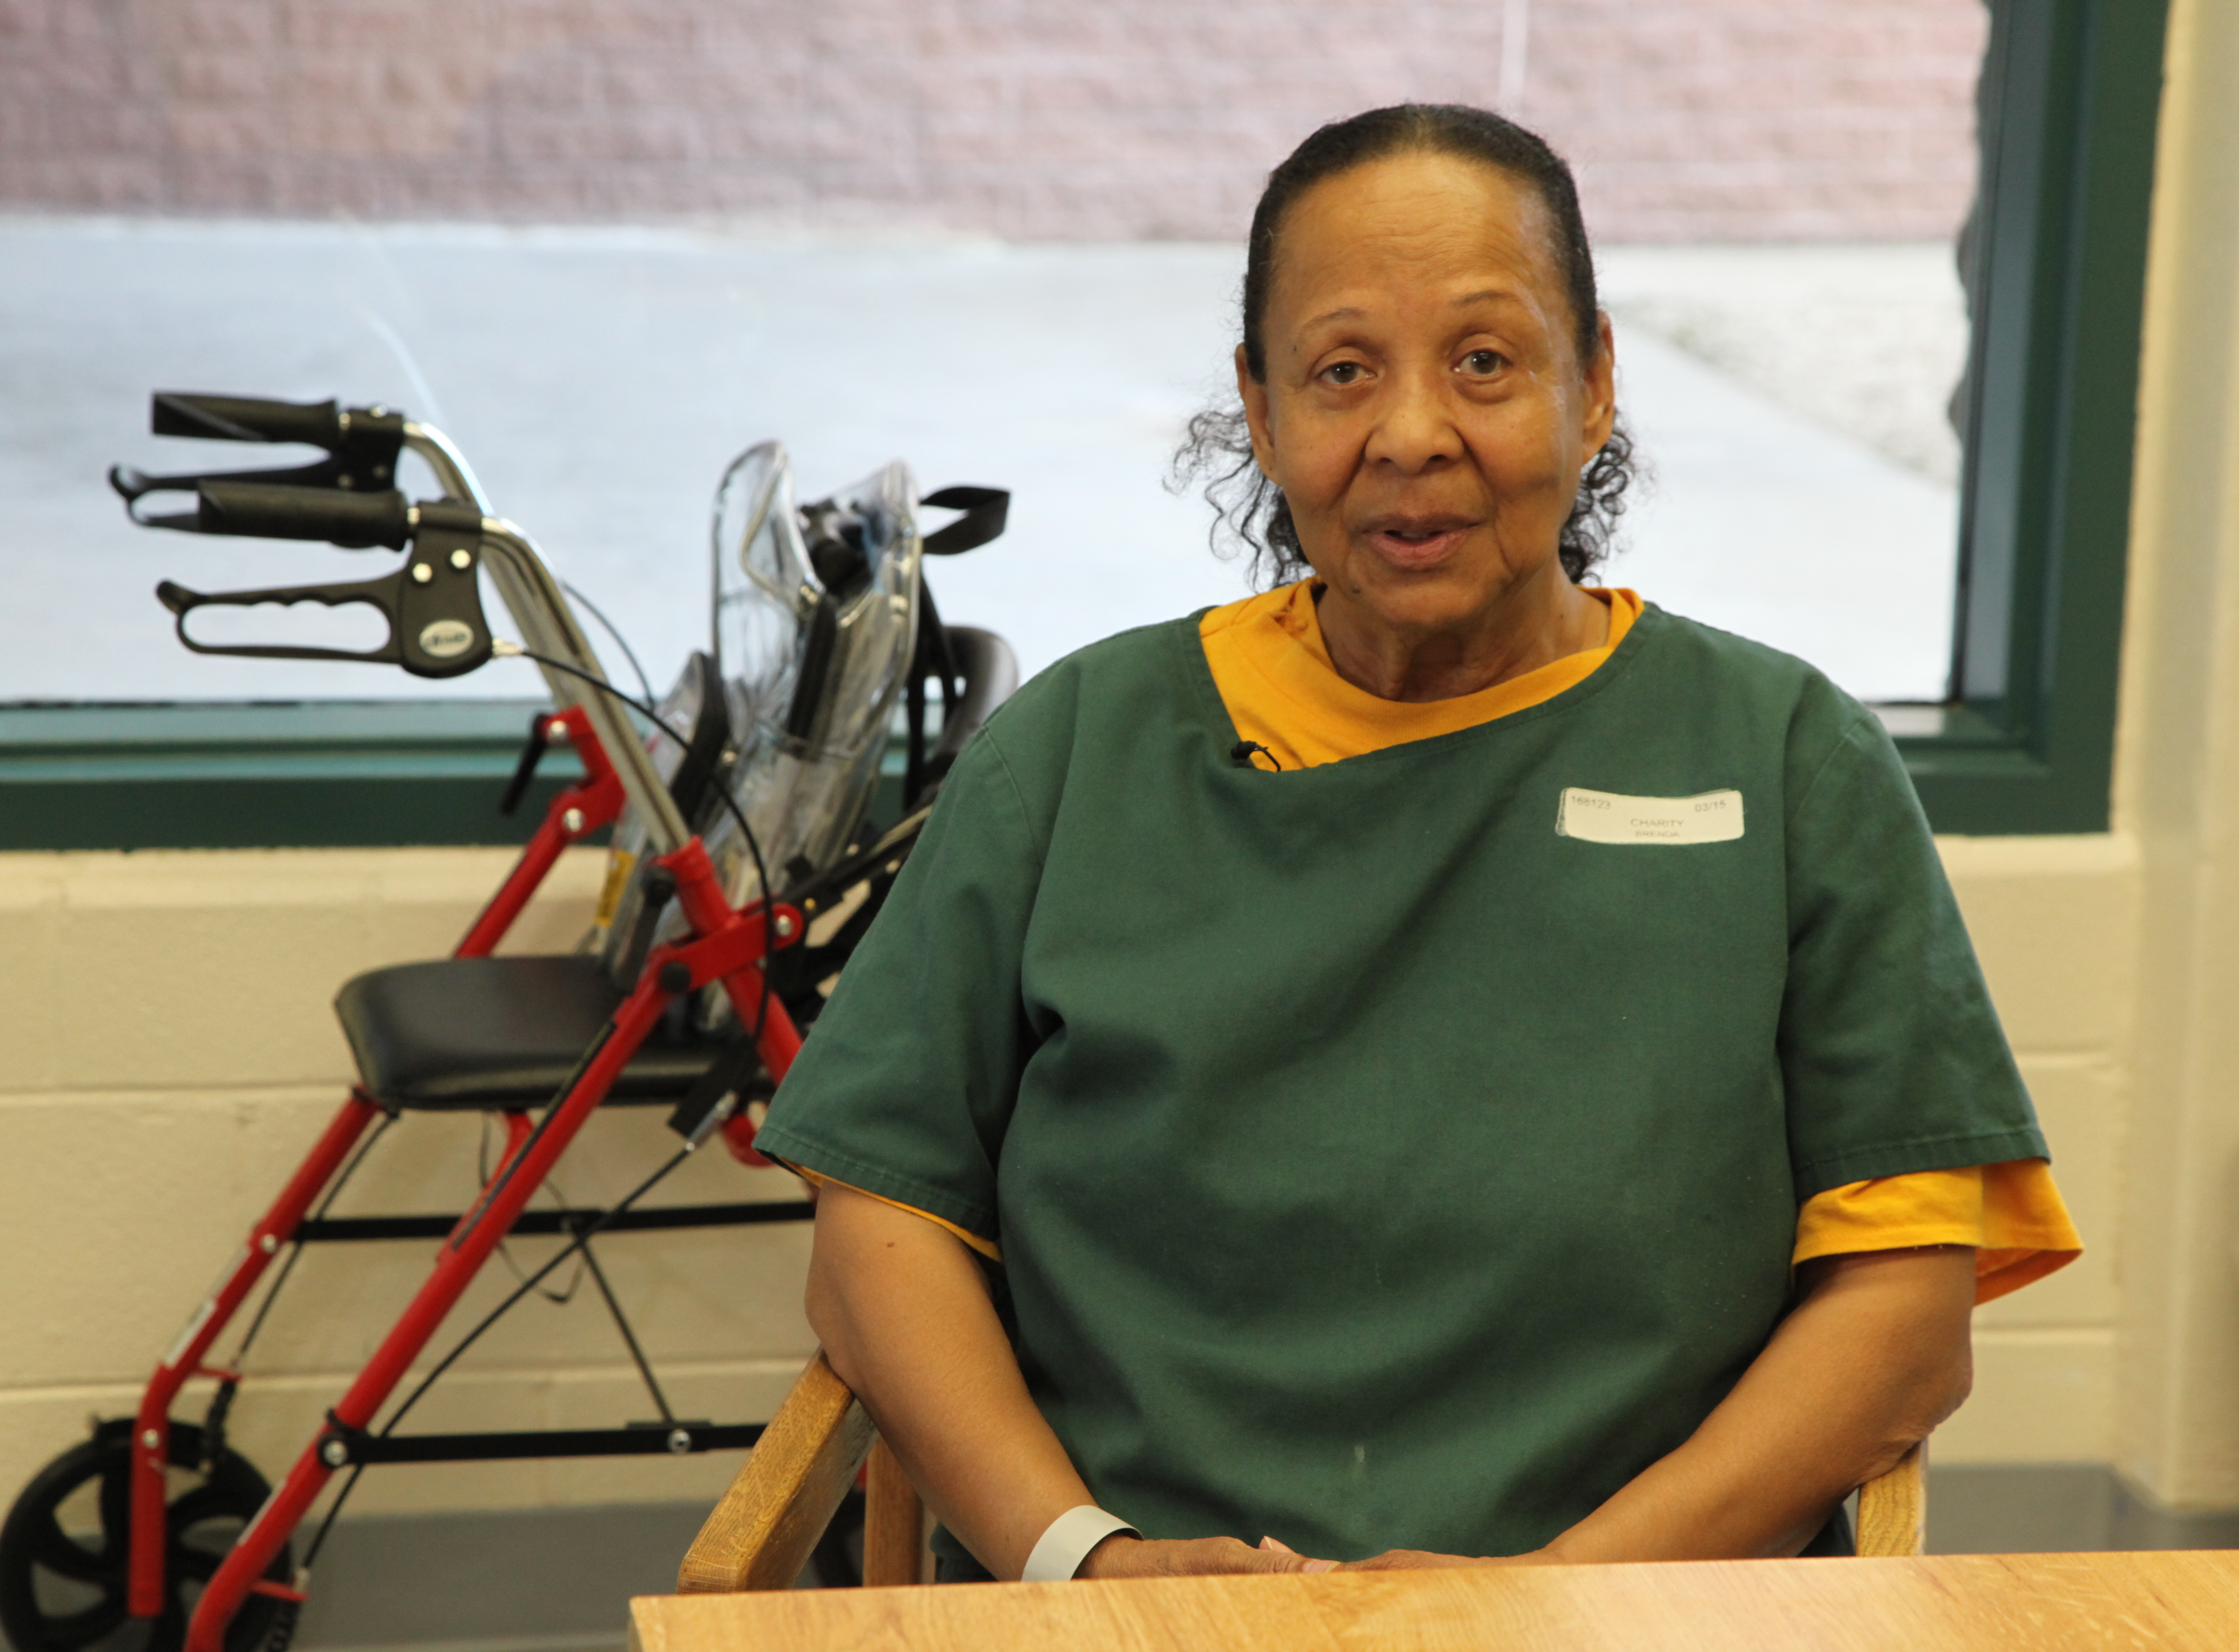
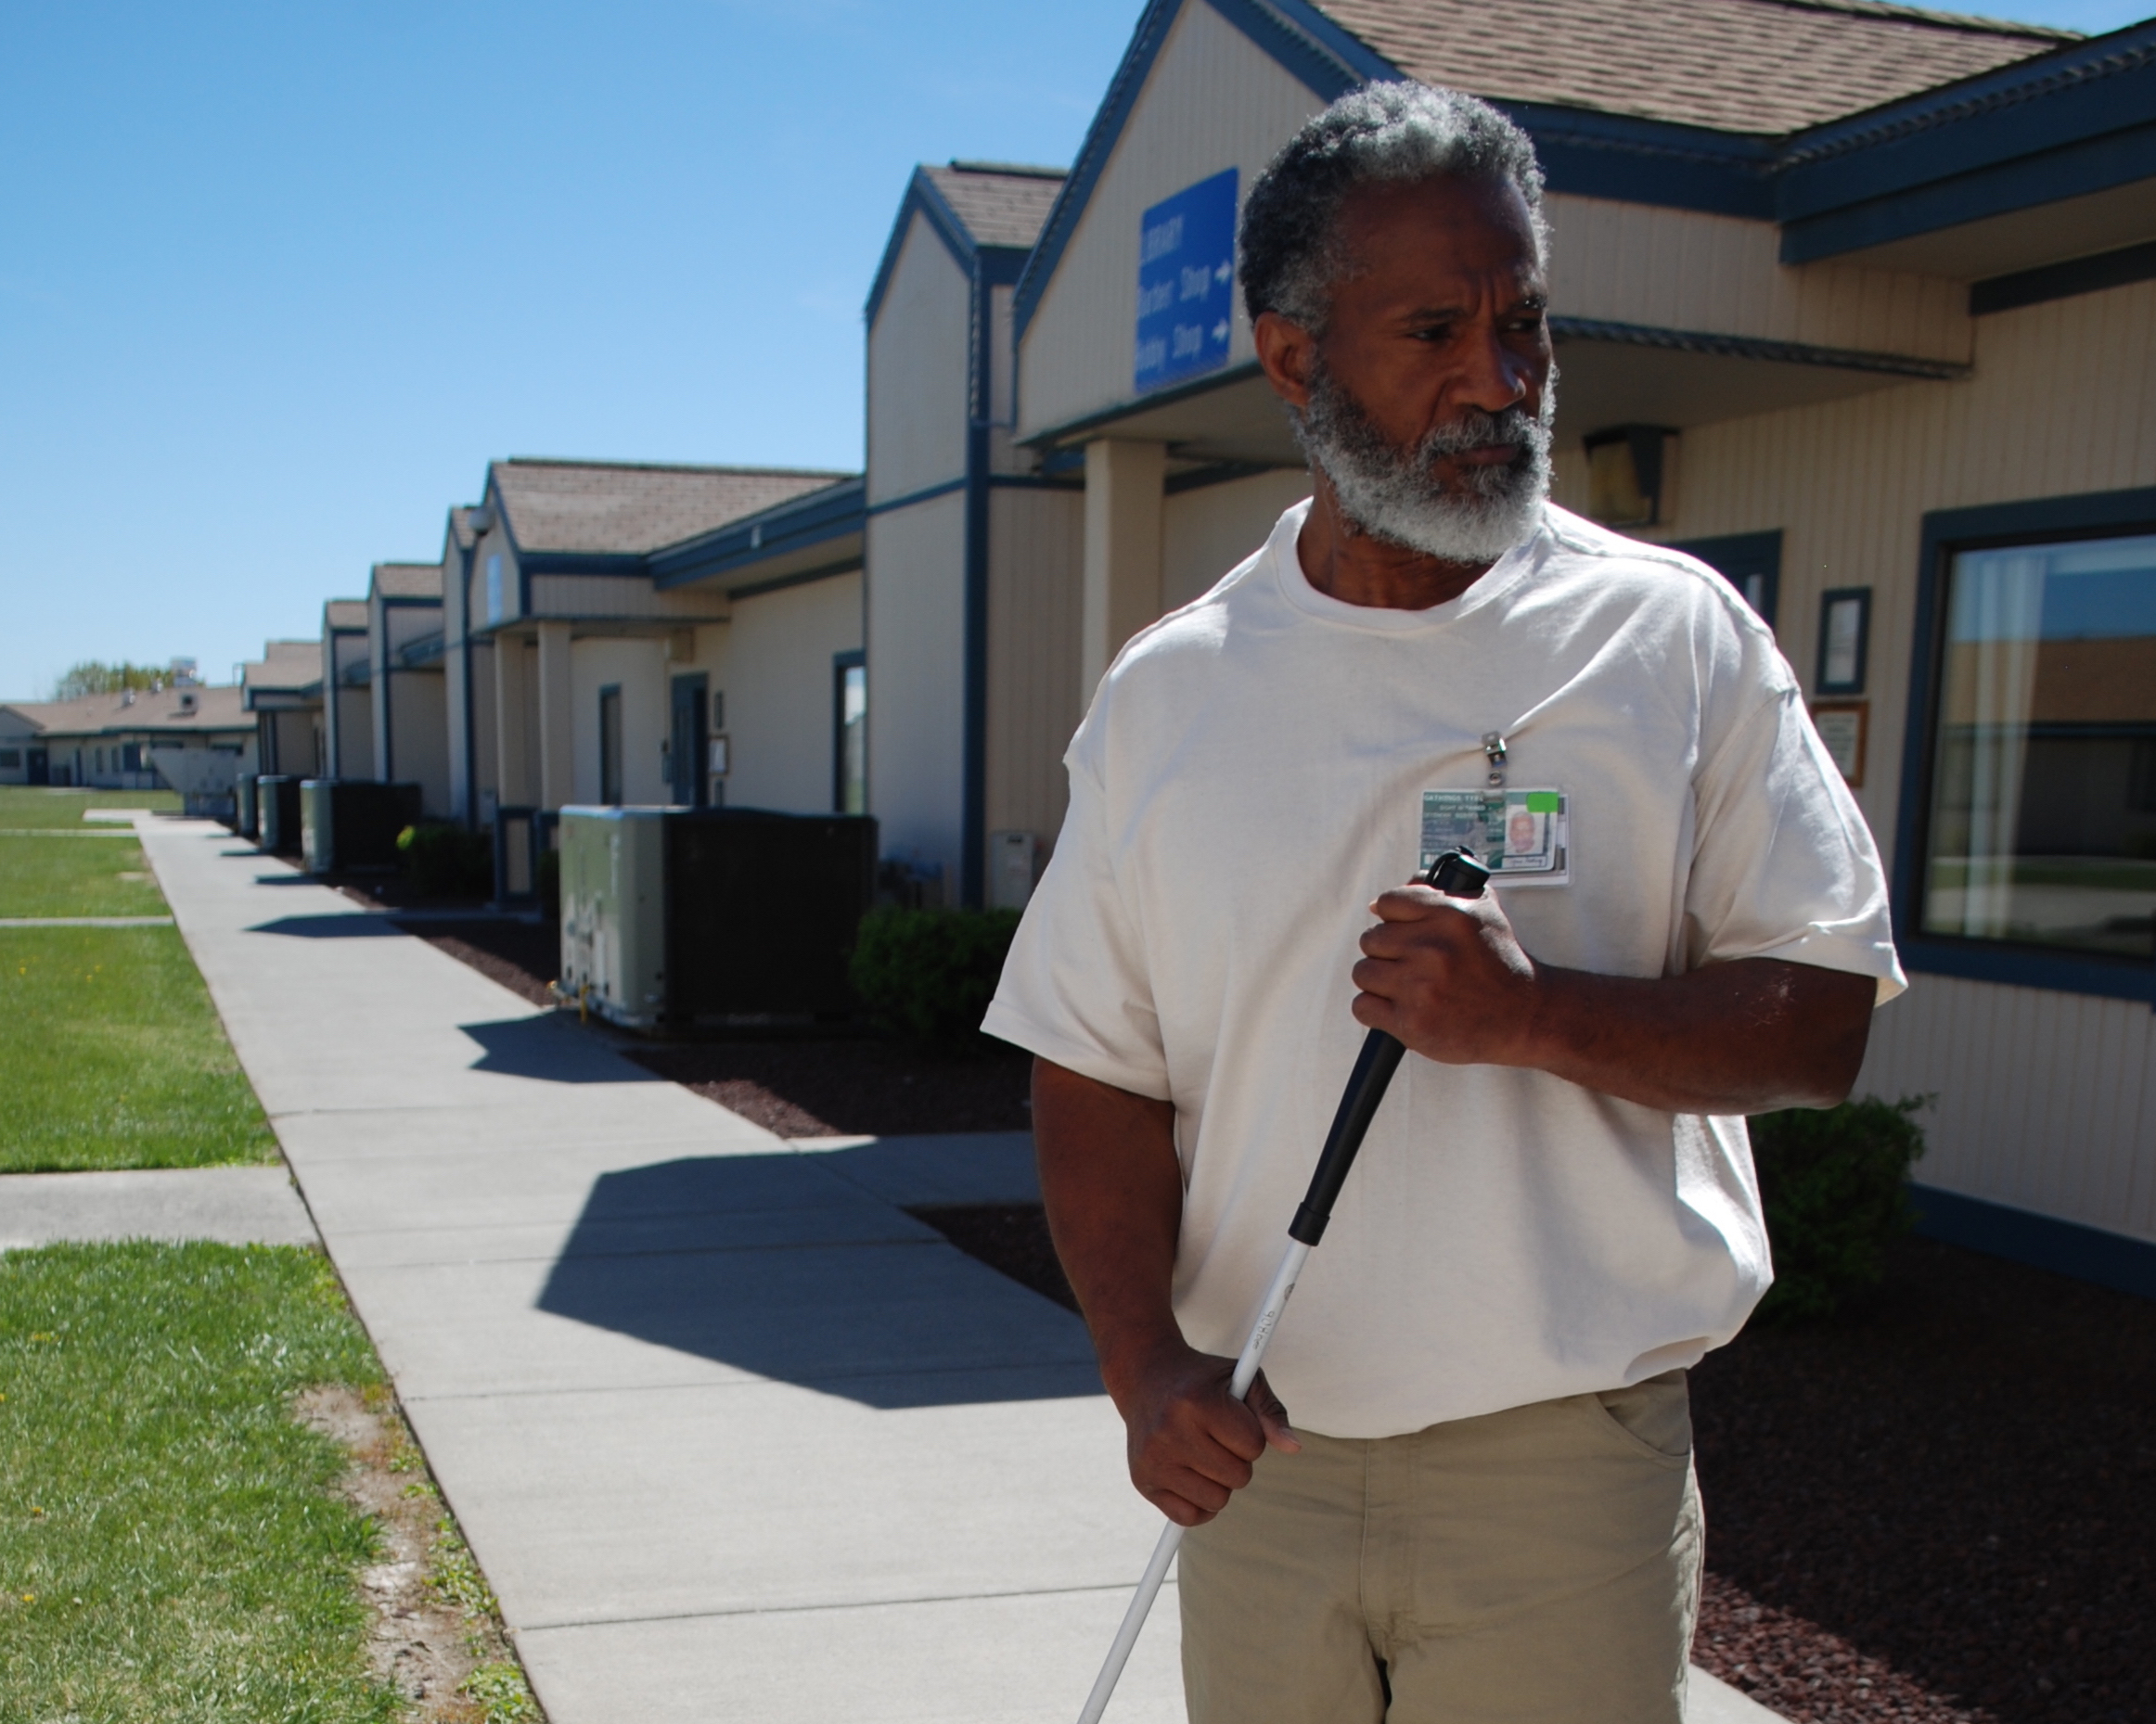
INMATE VOICES
Photo 1 Brenda Charity, an inmate from Colorado, sits near her walker.
Brenda Charity, Colorado
"My name is Tyrone Gathings. I have a vision disability. I was diagnosed with retinitis pigmentosa, RP. I was diagnosed with this back in 1979...

Right now, they got me going to Walla Walla Community College, and I really haven't accomplished anything. I would've liked to extend my education.

Like I said, I require visual aids in order to keep up with the rest of the class. I haven't been afforded any of that. Sometimes you're just put off in the corner to sit to the side, and it's kind of frustrating after a while. The way it is now, I'm just basically going back out there with no skills."

"My name is Brenda Charity. I came here in March of 2015, and we're at Denver Women's Correctional Facility. I've always been told by my doctors outside that if I try and use the elliptical, do light weights-- that helps my circulation and my heart.
So, I was on the elliptical and doing five-pound weights, trying to lift to strengthen myself, and my accommodations were taken away because of that...
Each time I would send in something to ADA, medical would send it, 'well, we saw her exercise. That's why we took it. If she can exercise, she doesn't need it.' Well, that's not true."
Photo 2 Tyrone Gathings, an inmate from Washington, stands in the yard with his white cane.
Tyrone Gathings, Washington

II. BACKGROUND

A. Overview of the P&A System

The P&A system was created in the 1970s after a series of news reports exposed the horrific institutional conditions in which people with developmental disabilities were housed. This news coverage prompted federal legislation to create a national network of P&As to advocate on behalf of people with developmental disabilities. Since that time, additional legislation has been passed, expanding the scope of P&As to include advocacy on behalf of all people with disabilities, in any setting, from the community to prison. This legislation also grants P&As the authority to monitor settings in which people with disabilities live, work, or receive services, as well as the power to investigate allegations of abuse and neglect of people with disabilities. This unique authority allows P&As to monitor and investigate in even the most segregated settings, and gives P&As access to individuals and records as they seek to enforce and defend the rights of people with disabilities. As increasing numbers of people with disabilities have become incarcerated, the P&A network has used its access authority to conduct monitoring and advocacy in the nation’s prisons.
Photo 3 AVID Attorneys tour a Washington State prison.

B. Methods of P&A Advocacy

In pursuing programmatic access and equality under the ADA, there are numerous methods of advocacy that may be employed by the P&A network. Given the statutory requirements in many of the authorizing statutes for P&As, agencies generally begin with the lowest level of intervention required, employing higher levels of advocacy as needed. This advocacy may range from information and assistance to individual inmates, to systemic monitoring or large scale litigation. For the purposes of this report, these levels of advocacy, described below, are separated into three categories: (1) individual advocacy within the prison, (2) systemic advocacy with corrections officials, and (3) administrative advocacy and litigation.

1. Individual Advocacy Within the Prison

P&As routinely provide information and assistance to inmates with disabilities over the phone or by letter. By providing prison policies, complaint forms, resources, and practical suggestions, P&As assist inmates with disabilities in navigating the prison system to access appropriate programs and services and support them in becoming effective self-advocates. This service also allows P&As to monitor common issues occurring in the prisons, and identify any potential systemic concerns as they arise.

P&As also undertake individual representation of inmates, often beginning any such case by communicating with various prison staff. Many corrections staff play a role in ensuring that inmates with disabilities have access to the programs and services at the facility. Therefore, when inmates and advocates are seeking accommodations in prison, there may be many different staff involved in providing or denying an accommodation, including custody staff, medical providers, and ADA coordinators. Through working with staff within the prison, P&As have been able to secure accommodations for inmates with disabilities.

2. Systemic Advocacy with Corrections Officials

P&As may also develop relationships with officials within a state’s department of corrections. Through meeting and sharing information with prison administrations at both individual facilities and headquarters, prisons are able to take proactive steps to address issues P&As identify. P&As also often use their federal authority to monitor the conditions in prison, meeting with inmates during such visits to discuss their concerns and identify individual and systemic issues related to disability. When P&As raise issues to prison officials that are identified during these monitoring visits, prisons are able to resolve many problems and avoid litigation.

3. Administrative Advocacy and Litigation

In an effort to protect the rights of inmates with disabilities, P&As have also turned to state administrative bodies and oversight agencies. Such advocacy has included filing claims with state human rights commissions and lodging complaints with agencies such as state health and education departments.

When litigation has been required, P&As have raised claims based on the Eighth and Fourteenth Amendments of the U.S. Constitution as well as the ADA and Section 504 of the Rehabilitation Act of 1973 (Rehab Act). While P&As have engaged in litigation in both state and federal courts on behalf of individual inmates, these cases are most often brought as class actions. In the last decade P&As have increasingly served as organizational plaintiffs in such cases, representing the interests of their constituents by challenging systemic conditions and practices that impact inmates with disabilities.

C. The ADA and Prisons

People with disabilities in state and federal prison are generally protected by Title II of the ADA and the Rehab Act. While the ADA extends to inmates in state-run correctional facilities, the Rehab Act applies to federal correctional institutions and state correctional facilities that receive federal funding. Together, these two statutes protect inmates with disabilities from discrimination in state and federal–run prisons and serve to ensure that they receive equal access to prison programming and services.

Title II of the ADA states: “no qualified individual with a disability shall, by reason of such disability, be excluded from participation in or be denied the benefits of the services, programs, or activities of a public entity, or be subjected to discrimination by any such entity.” In order to be considered a “qualified individual” an inmate must be
a person with a disability “who, with or without reasonable modifications to rules, policies, or practices, the removal of architectural, communication, or transportation barriers, or the provision of auxiliary aids and services, meets the essential eligibility requirements for the receipt of services or the participation in programs or activities provided by a public entity.” Thus, the ADA goes further than ensuring equal access to services and programs; it places an affirmative obligation on the facility to provide reasonable accommodations and modifications to inmates with disabilities to ensure they have access to such services. Whether a requested modification is “reasonable” is a fact-specific determination in which the interests of the inmate are balanced against the concerns of the prison.

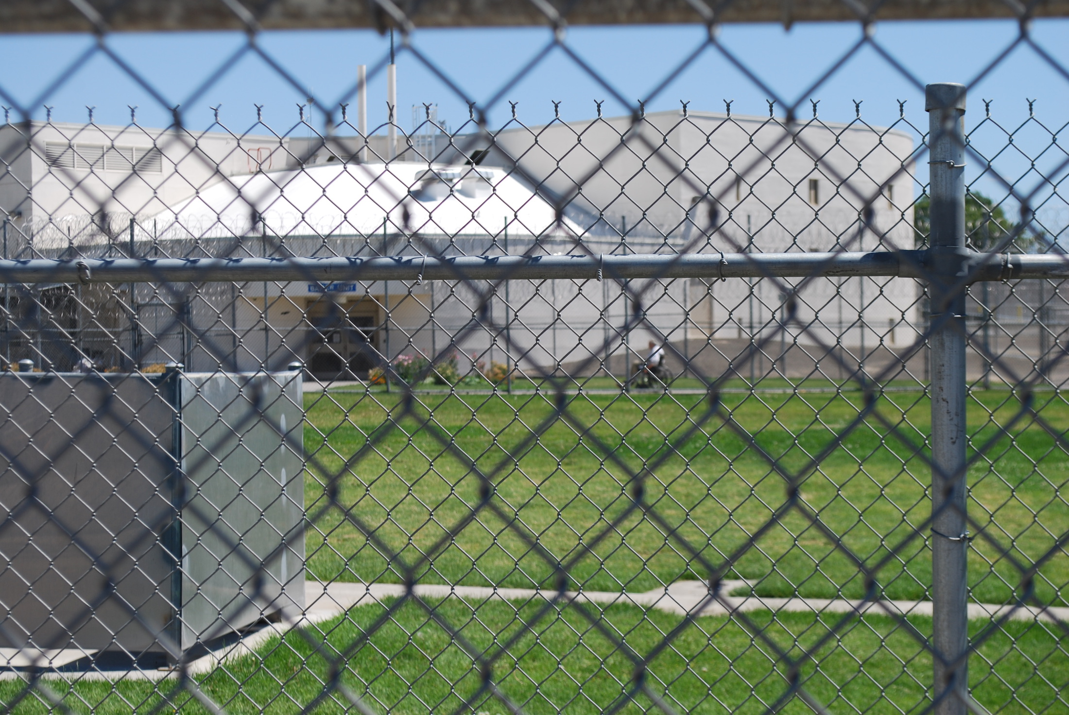
Photo 4 An inmate in a wheelchair through a fence.
Notably, the protections of the ADA extend not just to ensuring that the physical structure of a prison is accessible, such as ramps, wide hallways, and appropriate grab bars in bathrooms, but also to the programming within the prison. Therefore, if an inmate has a disability that limits their mobility such that they cannot access the dining area, under the ADA that inmate is being improperly excluded from participation in an activity and the prison is obligated to provide either modifications or accommodations that would allow the inmate to access the dining area along with the rest of the population. Similarly, an inmate with a cognitive disability who cannot participate in educational or treatment-related programming in prison due to his or her inability to process written information would be protected by the ADA and the prison would be responsible for providing that inmate with a reasonable accommodation to ensure programmatic access.

In addition to the general protections of the ADA, the implementing regulations of Title II provide specific direction with respect to accommodations in a correctional setting. For instance, the regulations make clear that prisons must house inmates with disabilities in the most integrated setting appropriate to the needs of the individual. They further direct that prisons must not house inmates in inappropriate security classifications simply because accessible cells are unavailable. They also preclude inmates with disabilities from being held in a medical unit unless they are actually receiving medical care or otherwise placed in facilities that do not offer the same programs and services as the facilities in which they would otherwise be placed. Finally, the regulations anticipate that inmates with disabilities will not be deprived of access to family members by being placed in distant facilities, simply due to disability.

III. PRISON ADVOCACY BY THE PROTECTION AND ADVOCACY SYSTEM

The P&A system has engaged in advocacy surrounding prisoners with disabilities for years but as the nation’s prison population ages and growing numbers of people with mental illness and cognitive disorders are incarcerated, many P&As are increasing their outreach and advocacy behind the prison walls. Outlined below are some of the recent successes the P&As have had in working with inmates with disabilities, separated into three categories: (1) hygiene, health, and safety, (2) accommodations in communication, and (3) access to programming and services. The case summaries in each category are organized by advocacy strategy: (1) individual advocacy within the prison, (2) systemic advocacy with corrections officials, and (3) administrative advocacy and litigation. The breadth and success of these examples demonstrates the critical role P&As have played in providing independent external monitoring and advocacy in our nation’s prisons while also making clear that much still needs to be done to advance and protect the rights of inmates with disabilities.

A. Hygiene, Health, and Safety

1. Individual Advocacy Within the Prison

- Disability Rights Washington provided assistance to an inmate with diabetes regarding his need for a therapeutic diet. Through an investigation, the P&A discovered that though the inmate had requested a therapeutic diet, none had been approved and the prison kitchen staff had refused to provide appropriate diet choices, resulting in problems for the inmate with his insulin levels and ostomy care. The agency advocated with the prison’s dietician to review the inmate’s request for a proper diabetic diet and meal planning. After negotiation, the dietician's recommendations were developed, refined, and implemented by the kitchen staff.

Two years later, the inmate again contacted the P&A, reporting that the prison had determined his therapeutic diet was no longer “medically necessary.” The P&A contacted the prison system’s dietician and medical director regarding the inmate’s continued need for a special diet. The dietician thereafter met with the inmate and renewed the therapeutic diet.

- Disability Rights Wisconsin was contacted by an inmate with diabetes seeking assistance. The inmate suffered from diabetic neuropathy in the state issued shoes and had been refused the therapeutic shoes he needed for years. Disability Rights Wisconsin conducted an investigation and uncovered a confusing multi-level process for accommodation and a failure to adequately monitor the man’s condition. Thereafter, the organization advocated with the prison to develop an active treatment plan for the inmate that included orthotics and appropriate footwear. The facility also provided additional health services training on the prison’s footwear policy.

- An inmate with cerebral palsy contacted Disability Rights Vermont, seeking an accommodation in the prison’s dining hall. After meeting with the inmate, the P&A assisted him in requesting a spill-proof cup for meals as a reasonable accommodation for his disability. Within a month, the medical department had purchased and provided a spill-proof travel mug for the inmate to use.

- An inmate with a bowel disorder contacted Protection and Advocacy for People with Disabilities, the South Carolina P&A, for assistance in obtaining a “toilet paper pass” after her pass was revoked by the prison’s medical staff. The pass had allowed her to obtain additional toilet paper at no cost, due to her bowel related issues; the pass was removed after medical staff determined that her condition no longer warranted additional toilet paper. The P&A successfully negotiated with the facility’s ADA coordinator to have the pass renewed.

- An inmate contacted Disability Rights Washington regarding his ileostomy care in prison. Upon investigation, DRW discovered that the inmate had been instructed to conduct maintenance of his ostomy bag in the medical unit of the prison rather than in his living unit. This system often resulted in delay of care and bag leaks. The prison then instructed the inmate to empty and change the ostomy bag in the prison toilet, using the sink to wash out the bag; this created an unsanitary condition for himself and caused conflict with other inmates. He was also prohibited from keeping bag maintenance supplies in his cell, thereby delaying care and putting him at risk of infection. The prison also refused to order needed supplies. After extensive negotiation with prison security and medical staff, the prison agreed to allow the inmate to conduct his ostomy care in his cell and keep his supplies on hand. The prison also agreed to provide needed supplies as well as additional nursing care and review.

- Disability Rights Mississippi met with a female inmate that used a catheter; the inmate reported that the prison was limiting the number of catheter bags she could have and preventing her from keeping cleaning supplies for her catheter in her cell. She reported that as a consequence, she was getting infections. Though the inmate had repeatedly raised these concerns with medical, staff were not responsive. The P&A contacted medical staff at the facility and advocated for increased access to both catheter bags and cleaning supplies. The inmate reports that the medical staff is now responsive to her needs.

- An inmate with paraplegia contacted Disability Rights Arkansas because he was denied medical care related to personal care and toileting. The inmate reported that he uses an enema to ensure that he does not develop any gastrointestinal issues resulting from his paralysis. While he had previously been allowed to do this in the medical area, he had been informed that he was taking too long and could no longer take care of his needs there, thus being forced to do this in the barracks. This deprived the inmate of needed privacy and caused severe anxiety, stress, and conflict with other inmates. Following advocacy by the P&A, the state’s corrections department agreed to allow the inmate to go to the medical area to take care of his needs.

- Disability Rights New York was contacted by an inmate with type 1 diabetes who was not permitted equipment for testing her blood glucose levels independently. The prison administration believed the testing equipment presented a safety and security risk, and directed that the equipment be held in the prison’s medical unit. The inmate was therefore required to visit the medical unit multiple times per day, which often delayed and/or prevented her from participating in prison programs. The P&A notified the prison and agency counsel that this practice presented an ADA violation, and advocated that she be permitted to keep her testing equipment safely in a locker on her housing unit. The prison agreed to allow the woman to possess a glucometer, lancets, alcohol pads, and test strips in her locker. A medical plan was drafted for the inmate and she is now able to effectively participate in prison programs.

- An inmate with significant migraines contacted the Connecticut Office of Protection and Advocacy for Persons with Disabilities because the constant illumination in the medical unit where he resided exacerbated his migraines. Because his migraines were so debilitating, he remained in bed with the blanket over his head for the majority of the day and night. The medical ward was a large room divided into four smaller rooms with one light switch that controlled all the lights. Over the course of several months, the P&A was able to advocate for the state prison system to individually wire each room so the lights could be turned off or on in each room.

- An inmate with Post Traumatic Stress Disorder and Shy Bladder Syndrome contacted Disability Rights Vermont for assistance in obtaining an accommodation for his disabilities related to providing mandatory urine samples for random drug testing. The inmate had received disciplinary reports for his inability to provide urine samples and though he had filed multiple grievances and ADA requests on his own, they had all been denied. The P&A assisted the inmate in requesting a reasonable accommodation in the form of alternative drug testing methods and also asked that the most recent disciplinary reports be expunged. The accommodation was granted, with mouth swabs being offered instead of requiring urine samples, and the disciplinary report was expunged.

- Protection and Advocacy for People with Disabilities, the South Carolina P&A, received a letter from an inmate who reported that his cell was not wheelchair accessible. Though the inmate had used a wheelchair for many years and had been in an accessible cell, he had recently been moved to a disciplinary unit that was not accessible. The inmate reported the toilet was inaccessible, he could not maneuver to and from his bed from the wheelchair, there was no table for him to use in the cell or any ramp to the unit’s outdoor recreation area, there was no appropriate shower chair, and his wheelchair no longer met his needs. After the P&A contacted the facility’s ADA coordinator, the inmate was transferred to a newer, more accessible facility and was approved for a more appropriate wheelchair. He was also provided with an accessible cell, trapeze bars, an aide to assist him in accessing the yard, a shower chair, and a lapboard.

- An inmate contacted Disability Law Colorado, reporting that her wheelchair, walker, and personal care assistant had been removed. The inmate reported that the removal had occurred after prison custody staff saw her engaged in light physical exercise that prison medical staff had suggested she do in order to gain strength. The P&A contacted the prison’s ADA Coordinator and advocated for the return of the inmate’s walker and personal care assistant, but not her wheelchair, which she no longer needed. As a result of that advocacy, her personal care assistant and walker were returned.

- Disability Rights Mississippi received a letter from a female inmate who reported her wheelchair was so badly damaged she was unable to move herself, forcing her to pay other inmates to push her. She also reported that her prosthetic had not been serviced during the two years she had been incarcerated and that as a result, she had been unable to use it for over six months. After the P&A contacted medical staff and a prison social worker, a new wheelchair was provided and the inmate’s prosthetic was serviced.

- An inmate contacted Disability Rights Washington for technical assistance, reporting that he had been in the segregation unit of the prison for almost two years without a wheelchair. As a result, the inmate reported dragging himself across the floor in order to conduct his daily activities. The inmate reported that he had been unable to access the yard or shower due to his inability to ambulate out of his cell. The P&A opened an individual investigation and found that while the inmate had been provided with a wheelchair for many years, it had been removed when he was placed in segregation. The records reflected that during that time, the inmate was noted by prison staff as being unable to ambulate in his cell due to his lack of a wheelchair. Upon the P&A commencing an investigation, the inmate’s wheelchair was returned and through negotiations with correctional administrative staff, the agency was able to facilitate the inmate’s transfer to a less secure setting.

- The designated P&A for South Carolina, Protection and Advocacy for People with Disabilities, received a letter from an elderly inmate that used a wheelchair, stating he was housed in the assisted living unit of the prison and he had fallen out of bed several times, with injuries. P&A staff contacted the prison and requested accommodations; the inmate now has a bed with side rails and inmate workers have been instructed to assist the inmate with transfers and remind him to have the rails up when he sleeps to prevent falling out. In addition, prison staff agreed to a medical assessment to determine if the inmate needs any further accommodations or interventions.

- An inmate contacted the Connecticut Office of Protection and Advocacy for Persons with Disabilities, requesting a double mattress. The inmate had several back surgeries and needed more cushion between the metal bed frame and his back. He had received a double mattress in his previous facility but upon being transferred to a new facility, was not provided with the accommodation because each prison had its own mattress policy. After contacting the ADA Coordinator for the corrections system, the P&A was able to get a new, thicker mattress for the inmate, a better accommodation then having a double mattress. As a result of this advocacy, the ADA Coordinator is also working on developing a system- wide mattress policy.

- Disability Rights Iowa was contacted by an inmate diagnosed with glaucoma and vision loss. His prescription eyeglasses were confiscated by prison officials as a result of the individual having altered the frames. Subsequently, he was denied access to a replacement pair of glasses and sought assistance from the P&A in obtaining them. The agency investigated the circumstances surrounding the seizure and destruction of the inmate’s glasses and prepared a demand letter, supporting the individual’s immediate right to the eyeglasses. The prison complied and made the individual an optometry appointment and ordered new glasses.

- Disability Rights Mississippi was contacted by an inmate who was an amputee with crutches that were the wrong size for him; the inmate also reported that he needed rubber grips for his crutches as his hands were calloused from use. P&A staff met with the inmate and he reported he had submitted kites and grievances regarding his need for new crutches for years but received no response from the prison. The agency contacted a social worker and medical staff at the prison and explained the inmate’s need for fitted crutches. The inmate was subsequently fitted for crutches and provided with rubber grips to protect his hands.

- An inmate with paraplegia contacted Disability Rights Arkansas because she was denied needed medical care and accommodations. The inmate reported that the prison required her to fill out a sick call in order to get an enema and denied access to needed physical therapy and appropriate footwear. The prison had also failed to ensure that the inmate had a special needs treatment plan or that she was admitted to the spinal cord chronic care clinic, in direct violation of their policy. As a result of the P&A’s advocacy, the inmate was allowed to have ready access to enemas, fitted for the correct medical shoes, obtained a follow-up physical therapy evaluation, and admitted to the specialized clinic.

- An inmate contacted Disability Rights Washington reporting that his orthopedic shoes and cane had been removed when he was placed in segregation. The P&A conducted an investigation and advocated for the return of the inmate’s mobility devices and for a transfer to a less restrictive and more accessible setting. The inmate thereafter received medical shoes while in segregation and was transferred to a less restrictive setting, where his cane was returned. The state prison system is now in the process of identifying orthopedic shoes that are approved for use in segregation and has clarified that assistive devices will be assessed on a case-by-case basis before taking them from an inmate in segregation.

- Disability Rights Iowa was contacted by an inmate diagnosed with glaucoma, dementia, and a foot bone disorder who stated he was regularly denied access to his medications, and had been denied access to prescribed orthotic footwear. The P&A completed an investigation and found medical records supporting the need for orthotic footwear that had not been provided to the DOC. The agency provided the state prison system with that information and requested that the inmate be evaluated by a qualified physician for orthotic footwear. As a result, the inmate was evaluated and given orthotic shoes. He was also provided consistent access to prescribed medications for glaucoma.

2. Systemic Advocacy with Corrections Officials

  - During routine prison monitoring, Disability Rights New York found that a prison did not have hoses for inmates to take hand-showers, rendering the showers inaccessible to many inmates with disabilities. After the P&A raised this issue with the facility administration and corrections’ counsel during the visit, the prison ordered and installed hoses in the inmate shower stalls. The facility installed removable hoses in its mental health and segregation units due to concerns with suicide risk on the unit.

  - During a monitoring visit, Disability Rights New York identified a rough and broken sidewalk at a facility. The prison administration agreed to prioritize repair of the sidewalk to render a safe and accessible path of travel.

3. Administrative Advocacy and Litigation

- An inmate with injuries to his hands contacted Disability Rights New York because he was deprived of his adaptive eating and writing utensils when placed in disciplinary confinement. The utensils had been removed from the inmate because they allegedly posed a threat to safety and security. The P&A wrote to lawyers for the prison and persuaded the prison administration to return the adaptive utensils to the inmate.

- Disability Rights Center – NH, the New Hampshire P&A, settled a case alleging violations of the ADA, Rehab Act, and the Eighth Amendment. In the case, the plaintiff inmate, who used a wheelchair and prosthetic arm, alleged that during his incarceration, his prosthesis was taken and he was permitted only a manual wheelchair, which he could not use with one arm. He also alleged he was held in a maximum security cell with no accessible toilet or shower and he suffered injuries as a result of attempting to transfer himself from his wheelchair to the toilet. Since settlement, the prison has installed an accessible cell in the maximum security unit, as well as an accessible shower.

- Following a year-long investigation and report, Alabama Disabilities Advocacy Program, the P&A for Alabama, along with co-counsel Southern Poverty Law Center, filed a federal lawsuit against the state’s department of corrections, alleging violations of the Eighth Amendment as well as violations of the ADA and Rehab Act. The lawsuit alleged, among other things, that facilities and programs in almost every prison in the state have architectural barriers to inmates with mobility impairments, creating an unsafe and inaccessible environment. In 2016 the parties reached settlement on the ADA and Rehab Act claims, wherein the state’s prison system agreed to remove all architectural barriers within the prisons, including in living units, bathrooms, and showers. The prison further agreed to implement a tracking system for identifying people with disabilities and their specific needs and to create an inclusive emergency preparedness plan. Extensive ADA training for agency personnel was also required in the settlement, as well as the creation of a separate grievance and appeals process for ADA compliance concerns. Finally, all 28 of the state’s prisons must have an ADA coordinator, overseen by an appointed statewide coordinator.

- Advocacy Center of Louisiana, the P&A for Louisiana, filed a lawsuit in federal court on behalf of a prisoner with vision impairments. The lawsuit alleged violations of the ADA and Rehab Act. The subsequent settlement directed that the prison assign the inmate to a bottom bunk with access to an electrical outlet for his assistive devices; it also directed that the prison provide protective padding for the bunk and situate it in an accessible area. The settlement further anticipated that medication and meals would be delivered to the inmate on his unit or, in the event of unusual circumstances, the prison would assign an individual to escort the inmate to pill call and meals. It also directed that the prison provide the inmate with a white cane as well as training in its use. Finally, the prison agreed to ensure shower chairs are available in the inmate’s living unit and that the shower drain is covered.

- The P&As from Connecticut, Vermont, and New York, along with other prisoner’s rights groups, filed an amicus brief supporting the federal lawsuit of an inmate challenging a New York prison’s refusal to allow him to use his motorized wheelchair in prison. The correctional facility has a blanket ban on motorized wheelchairs because of alleged safety concerns. Instead of a motorized wheelchair, the inmate was forced to rely on other inmate "pushers" for access to meals, medical care, and basic hygiene, and often missed these essential services because his assigned pushers failed to show up or refused to assist him. The P&As argued that the prison’s blanket ban violated the ADA. That case is pending.

- In 2016 Disability Rights Florida filed a federal lawsuit against the state’s department of corrections. Prior to filing, the P&A had conducted an investigation for almost two years, reviewing thousands of records and interviewing inmates across the system. The suit accuses the prison system of routinely violating the ADA and Rehab Act, as well as the Eighth Amendment and Due Process Clause of the Fourteenth Amendment. Among the claims presented are allegations that certain prisons are not fully wheelchair accessible, and that the prison system excludes prisoners from work programs and other services because of their disabilities, while retaliating against them for attempting to exercise their rights under these laws. The P&A is seeking an injunction requiring the state’s department of corrections to, among other things, comply with federal disability laws, provide prisoners with the aids and services they need, structurally modify prisons where necessary to ensure equal access, and train its staff to ensure ongoing compliance.

B. Accommodations in Communication

1. Individual Advocacy Within the Prison

- Disability Rights Washington provided an inmate who was blind with self-advocacy assistance over the telephone. Following that assistance, the P&A sent the inmate resources and information via audio CD as well as in written form as an accommodation. After learning that the prison had refused to provide the inmate with the CD, the P&A took on the case for limited advocacy. After a record review, Disability Rights Washington coordinated with the local facility’s ADA Coordinator as well as the ADA Compliance Officer for the prison system. The inmate was given full access to the CD under the prison’s legal mail policy and in accordance with the prison’s policy regarding accommodations for inmates with disabilities.

- An inmate with a hearing impairment contacted Disability Rights Vermont because the prison had denied him hearing aids. The P&A met with the prison, which reported that the inmate’s hearing had been evaluated and the physician had determined he had normal functioning hearing. Upon further information from the inmate, the P&A learned that the “hearing evaluation” consisted of the physician asking him questions behind his back in a low voice. The P&A then assisted the inmate in submitting an accommodation request for a formal hearing function test and for hearing aids, both of which were granted.

- Disability Rights Iowa was contacted by an inmate diagnosed with blindness and traumatic brain injury who was requesting assistance in obtaining audiobooks and assistance writing letters as accommodations while incarcerated. After speaking with the inmate, the P&A contacted the prison and the service provider of the audiobooks and arranged to have the individual’s audiobook privileges reinstated. The P&A also worked with prison staff to identify other available resources and ensure access to necessary accommodations. As a result of this advocacy, the inmate was provided regular access to a library selection of audiobooks at no charge to him, as well as personal assistance reading and writing, so he can communicate via mail effectively.

- An inmate with significant learning disabilities contacted Disability Rights Vermont, reporting that he has extreme difficulty reading and writing and had therefore requested to be allowed two to three telephone calls per month to his minor children, with the prison covering the cost of those calls in lieu of the postage otherwise provided by the prison for inmates to write letters. The prison denied his request and the inmate was instructed to work with a volunteer outside the prison to help him with his correspondence. As an alternative, the inmate asked to participate in a program at the prison that allows inmates who are fathers to dictate a book on tape and send it to their child. The inmate informally requested that instead of dictating a book on tape, he be allowed to dictate a letter to his children. That request was denied as well. The P&A intervened and assisted the inmate in submitting an appeal to the commissioner; in the appeal the inmate reiterated his request for an accommodation. The commissioner reversed the denial and granted the inmate’s request to dictate letters to his children on tape at no cost, as an accommodation for his disability.

- A deaf inmate contacted the Connecticut Office of Protection and Advocacy for Persons with Disabilities about several issues, including the need for hearing aids, lack of interpreters for religious services and medical appointments, lack of access to Alcoholics Anonymous meetings due to the absence of an interpreter, and limited access to TTY, a telecommunications device. The P&A provided technical assistance to the inmate to assist him in requesting the needed accommodations and accessing the prison’s grievance process. The P&A also contacted the state’s department of corrections, after which the state agreed to provide the inmate with interpreters for religious and medical appointments as well as other programming. The inmate was also provided with an audiology appointment to assess his need for hearing aids.

- Disability Rights Iowa was contacted by an inmate diagnosed with hearing loss who was being denied access to a hearing aid, even though it was recommended by a specialist providing treatment to the inmate. At the request of the P&A, the individual was evaluated by the prison system’s medical director, and subsequently by physicians at a local hospital. The inmate’s need for a hearing aid was confirmed in writing to the P&A, which used that recommendation to successfully advocate for the inmate to obtain the hearing aids.

- An inmate who is deaf and requires the use of an American Sign Language (ASL) interpreter and TTY for communication contacted Disability Rights Vermont after the prison had denied the inmate’s repeated requests for an ASL interpreter for meetings, counseling, medical visits, and peer support groups. The P&A worked with the inmate to file a grievance and appeal. As a result of the appeal, the inmate received interpreter services for mental health, medical appointments, and disciplinary hearings. He also was given access to TTY phone services. The prison subsequently entered into a contract with an interpreter to assist the inmate in other areas of planned or elective activities.

- An inmate with bilateral hearing loss contacted the Connecticut Office of Protection and Advocacy for Persons with Disabilities and reported that both of his hearing aids had stopped working. He reported that he had repeatedly requested that the prison fix them but they had failed to do so. The inmate reported that, as a consequence, he attended a parole hearing without these devices, or any other accommodations, and was unable to effectively communicate during the hearing. The inmate was denied parole. The P&A advocated for another hearing, at which the inmate was provided one working hearing aid and he was granted parole. After the hearing, the state’s prison system provided the inmate with two working hearing aids, as prescribed by the audiologist.

2. Systemic Advocacy with Corrections Officials

- An inmate who was deaf contacted Disability Rights Wisconsin, reporting that the prison had shut-down the free TTY phone service in the facility due to misuse by other inmates. As a result, in order to communicate with his family and friends, the inmate was forced to pay a prohibitively high fee for the limited use of a phone in the social worker’s office. Disability Rights Wisconsin partnered with the state’s Department of Health Services’ Office for the Deaf and Hard of Hearing and recommended that the prison provide “Z-phone” technology, which allows deaf and hard of hearing individuals to direct-dial another party and sign or use voice-over technology with the help of a remote video interpreter. That technology was thereafter piloted in the prison; the state is currently evaluating whether the technology may be implemented system wide.

- Disability Rights New York successfully advocated with the prison superintendent and counsel for the state’s department of corrections for installation of specialized software and computers in a prison law library to provide equal access to prisoners with visual impairments.

- In order to ensure effective communication for prisoners with disabilities, Disability Rights New York contacted the state’s department of corrections to advocate for the inclusion of videophones as a key and necessary feature in the prison’s communications system. The corrections system is currently viewing product demonstrations of videophones to be included with an overall communication upgrade.

- After numerous reports that the prison was using inmates as interpreters for prisoners who were deaf or hard of hearing, Disability Rights Oregon negotiated with prison administration to create a new policy regarding effective communication within the prisons. The new policy designated an ADA coordinator to oversee services for deaf inmates, required the provision of materials in a variety of alternative formats, and mandated the use of qualified interpreters, TTY, and other auxiliary aids and services as needed. It also outlined the provision of auxiliary aids for inmates, both at intake and while incarcerated, and directed that an inmate’s choice as to the means of communication should be the primary consideration in providing needed accommodations. The negotiated settlement greatly improved conditions for deaf and hard of hearing prison inmates. However, recent complaints indicate that untrained inmate interpreters are still being used in some situations that compromise the safety and welfare of the deaf and hard of hearing inmates. Pro bono counsel is currently considering a lawsuit to further limit the use of inmate interpreters.

- Disability Rights Pennsylvania was contacted by state prisoners who are deaf or hard of hearing, who reported that they were not being provided with effective communication or access to the prison’s services and programs. Inmates reported that interpreters were not being provided on a regular basis for classes or doctor appointments and use of TTY for outside calls was either severely restricted or not available at all. The P&A also received complaints that prisoners with broken hearing aids may go months, if not years, without repair or replacement. The agency contacted legal counsel for the prison system regarding the prison’s obligations under the ADA and the Rehab Act and as a result of these discussions, one prisoner went from having one faulty hearing aid to two functional hearing aids. The state prison system also developed specialized cell blocks for prisoners who are deaf or hard of hearing; the system also now provides video interpreting services for medical services, counseling, and classes. Prisoners have access to assistive technology devices like vibrating watches, TTYs, and video monitors and scrolling LED displays that provide announcements and other information. The state’s prisons are also in the process of implementing videophones and the P&A is currently advocating for expanded access to this technology.

- Following individual advocacy in relation to a deaf inmate, the Connecticut Office of Protection and Advocacy for Persons with Disabilities began working with the state’s prison system to place videophones in its facilities. Once a vendor has been identified, a pilot project will be launched in one facility. This case is ongoing.

3. Administrative Advocacy and Litigation

- Equip for Equality, the P&A for Illinois, filed litigation alleging systemic discrimination against deaf and hard of hearing inmates, including failing to provide ASL interpreters, technological assistance and other alternate forms of communication. The claims were based in the ADA, Rehab Act, Religious Land Use and Institutionalized Persons Act, and the First, Eighth, and Fourteenth Amendments of the U.S. Constitution. As a result of these systemic violations, the plaintiffs alleged that inmates were endangered and deprived access to a variety of prison services and programs, including religious services, healthcare, educational and vocational programs, telephones, televisions, library services, disciplinary proceedings, grievances, and pre-release programs. Settlement negotiations in this case were unsuccessful. Class certification has been granted and the parties are now preparing for trial.

- Disability Rights Idaho filed a federal lawsuit on behalf of an inmate who was deaf, alleging violations of the ADA and the Rehab Act for the prison’s failure to provide the inmate with access to video phone technology. After extensive discovery, the state’s correctional department settled the case by agreeing to provide the inmate with reasonable access to the technology. Under the terms of the settlement, the video phone was initially placed in a staff member’s office for use after hours. However, the settlement anticipates that the prison will relocate the phone to the dayroom and provide increased access when technologically feasible.

- Following a year-long investigation and a report, the Alabama Disabilities Advocacy Program, the P&A for Alabama, along with co-counsel Southern Poverty Law Center, filed a federal lawsuit against the state’s department of corrections, claiming violations of the Eighth Amendment as well as the ADA and Rehab Act. The lawsuit alleged, among other things, that inmates with intellectual disabilities cannot adequately access the prisons’ medical system due to its reliance on written requests, which many inmates with cognitive disabilities cannot fill out. It further alleged that inmates with hearing impairments are unable to access medical services because they often miss medical call outs and pill line due to the prison’s failure to accommodate their disabilities. In 2016 the parties reached settlement on the ADA and Rehab Act claims. In the settlement agreement, the state’s prison system agreed to implement a tracking system for identifying people with disabilities and their specific needs and to create an inclusive emergency preparedness plan. Extensive ADA training for agency personnel was also required, as well as the creation of a separate grievance and appeals process for ADA compliance concerns. Finally, all 28 of the state’s prisons must have an ADA coordinator, overseen by an appointed statewide coordinator.

- As the designated P&A for Delaware, the Disabilities Law Program at the Community Legal Aid Society filed a claim under Delaware’s Equal Accommodations Act, a state statute similar to the ADA, on behalf of an inmate who was deaf. The claim was filed before the Delaware Human Relations Commission, an administrative body charged with investigating and enforcing discrimination complaints within the state. After a multi-day hearing, the Commission found that the prison’s delay in providing the inmate access to TTY for over nine days and the subsequent limitations placed on his use of the TTY (including requiring him to request calls through his counselor, limiting call times, limiting use to family emergencies and legal calls) amounted to a denial of reasonable accommodations. The Commission also found that the prison had failed to provide qualified interpreters for prison programming and the provision of programming via computer as opposed to in a group setting was not a reasonable accommodation. The Commission further found that given the importance and infrequency of classification reviews, qualified interpreters should have been provided for the inmate and requiring the inmate to communicate only in writing, when he does not fully comprehend spoken English, amounts to a denial of reasonable accommodations as well. The Commission awarded the inmate compensation for his emotional distress and fined the prison; it also awarded attorney’s fees and costs.

- The Advocacy Center of Louisiana, the P&A for Louisiana, filed a lawsuit in federal court on behalf of a prisoner with vision impairments. The lawsuit alleged violations of the ADA and Rehab Act. The subsequent settlement directed that the prison provide the inmate with access to a closed circuit television (CCTV) in the library as well as a hand-held CCTV. The settlement also directed that the prison maintain all inmate forms in large print.

- The National Disability Rights Network, along with the National Association of the Deaf, submitted comments to the Federal Communications Commission in response to 2016 rulemaking regarding interstate phone services for inmates. While the comments addressed the need for improved rates and access to TTY, they also identified the growing need for a more comprehensive communication system for inmates who are deaf, hard of hearing, or have communication disabilities. Specifically, the comments highlighted the need for increased access to telecommunications relay services and video relay services in the correctional setting. In support of this recommendation, the organizations pointed to recent litigation brought by the Idaho P&A around this issue; the comments also requested clearer guidance as well as meaningful enforcement from both the Commission as well as the U.S. Department of Justice on issues relating to telecommunication access for inmates.

- After almost two years of investigation, including reviewing thousands of pages of records and interviewing dozens of inmates, Disability Rights Florida filed a federal lawsuit against the state’s prison system. With the P&A serving as organizational plaintiff, the suit accuses the state prisons of routinely violating the ADA and Rehab Act, as well as the Eighth Amendment and Due Process Clause of the Fourteenth Amendment. Among the claims presented is an allegation that the state’s prison system has failed to provide qualified sign language interpreters and other auxiliary aids and services during critical interactions such as medical appointments, disciplinary hearings, and educational programs, and has further failed to provide meaningful telecommunications access to deaf prisoners. The P&A is seeking an injunction requiring the system to, among other things, comply with federal disability laws, provide prisoners with the aids and services they need, structurally modify prisons where necessary to ensure equal access, and train its staff to ensure ongoing compliance.

- The Disabilities Law Program at the Community Legal Aid Society, the Delaware P&A, commenced an administrative proceeding on behalf of an individual on parole who was not provided with an interpreter for meetings with his parole officer. The claim was filed with the state’s Human Relations Commission and alleged violations of the state’s Equal Accommodations Law. The case was settled, resulting in the creation of a new policy that required the provision of qualified sign language interpreters for all probation and parole meetings with deaf or hard of hearing individuals. The settlement also provided for additional training for staff regarding TTY and deaf relay services. The individual plaintiff was also awarded damages.

C. Access to Programming and Services

1. Individual Advocacy Within the Prison

- An inmate who had an amputation and had used a prosthetic since childhood contacted Disability Rights Vermont, reporting that when he had entered prison a year prior, the prosthetic was old and in need of replacement; the inmate also reported that he had received surgery on his leg during this incarceration, which then required a new prosthetic fitting. The prison provided the inmate with a wheelchair and told him that he would be evaluated for a new prosthetic device. When the inmate met with the P&A, he had been waiting for the replacement for months. The P&A assisted the inmate in filing a request for an accommodation, seeking the promised prosthetic. The prison thereafter denied the request, arguing that the inmate had one leg and had been provided with a wheelchair, and that no additional accommodation was necessary because he was at a one-level accessible facility. The P&A appealed the decision, arguing that the inmate could not access specific programs and services without the use of the prosthetic. The denial was reversed and the request was granted; the inmate is now in the process of being fitted for a new prosthetic.

- During routine monitoring, Disability Rights Washington noted that a facility’s infirmary was being used as long-term housing for some inmates with serious medical conditions. While the inmates were medically stable, they were considered vulnerable and were therefore segregated from the rest of the prison population. The P&A sent a letter to the facility’s superintendent as well as to the state department of corrections’ officials, identifying this as an issue and requesting follow-up. The P&A was thereafter advised that the individuals had been moved from the infirmary and into minimum security housing, where they were integrated with the general population.

- Disability Law Colorado was contacted by an inmate who was nearing release and seeking assistance in reinstating the federal social security benefits he had received prior to incarceration. The inmate reported there was a program available at the prison that was designed to assist inmates in accessing such benefits but his counselor was denying him access to the program because he believed the inmate should obtain employment rather than access the disability benefits. After contacting counsel for the state’s department of corrections, the P&A was informed that the counselor was now providing the inmate with information and assistance on reinstating his disability benefits upon parole.

- An inmate with physical disabilities contacted Disability Rights Wisconsin regarding his need for accommodations related to his release planning. Specifically, he needed accessible housing and reported that there was no way for him to request that accommodation in relation to his release planning. Disability Rights Wisconsin worked with the state’s Division of Community Corrections to create a new policy for the Division that would provide a mechanism for individuals to have accommodations incorporated into their release plans.

- An inmate using a wheelchair reported to Disability Rights New York that she was placed on “medically unassigned” program status, and therefore could not participate in any programming. As a result of not participating in a vocational program, this inmate could not earn merit time towards an early release date. During a monitoring visit, the P&A reviewed the programming at the facility and advocated for the inmate’s participation in either of two mainly sedentary vocational programs, with or without accommodations. The facility’s superintendent agreed that all “medically unassigned” inmates would be individually reviewed and assessed for programs. The inmate who reported this problem was thereafter assigned and has completed a vocational course.

- An inmate with mental illness and learning disorders contacted Disability Rights Vermont reporting that he needed an accommodation in order to participate in a mandatory prison program. The inmate had recently been removed from the program for 30 days because he was “not meeting expectations.” The inmate reported that he had required extensive special education services while in school, with one-on-one assistance, and had not graduated. When the inmate asked the prison for assistance in participating in the mandatory program, he was told that he could use his "peers" to help him. The P&A assisted the inmate in filing a grievance regarding the lack of accommodation and the inmate’s removal from the program. The prison thereafter removed the requirement that the inmate complete the program, due to his disability, and stated that this waiver from the program would not affect the inmate’s release date.

- An inmate with a disability contacted Disability Rights Washington to report that a family member had been delayed in the prison’s visitor screening process due to her disability. The inmate reported that the visitor’s use of a wheelchair and oxygen tank required her to be hand searched before visiting and that, as a result, she had been admitted later than other visitors. The inmate had attempted to grieve the issue on his visitor’s behalf, due to her disability, and the grievance had been rejected. The P&A contacted the grievance program manager for the prison system, as well as the grievance coordinator for the facility, and advocated for the grievance to be reviewed and investigated. The grievance was thereafter processed and the investigation resulted in changes to the visitor screening process to ensure that visitors with disabilities are not delayed.

- Disability Rights New York was contacted by a female inmate who had been recommended for the prison’s specialized residential trauma treatment program for women who have histories of physical or sexual abuse. The inmate could not participate in the program because its second-floor location rendered it inaccessible to women with mobility impairments. The P&A toured the program on a monitoring visit, interviewed several women who had been denied access to the program because of their mobility impairments, and reviewed their mental health and programming records. Disability Rights New York then wrote to the commissioner of the state’s prison system, as well as facility administrators, notifying them that the P&A was prepared to litigate the ADA and Rehab Act violations unless this critical program was relocated. The state’s prison system thereafter agreed to relocate the trauma treatment program to an accessible housing unit. The program was moved to its new location, and the prison publicized to inmates that the program is now accessible.

- Protection and Advocacy for People with Disabilities, the P&A for South Carolina, received a request from an attorney representing a death row inmate with an intellectual disability, a speech impairment, and schizophrenia. Although a court had previously ordered that the inmate receive appropriate mental health services in light of his intellectual disability, the inmate had not been transferred to a more appropriate facility. After the P&A contacted the system’s ADA coordinator, the inmate was transferred to a prison designed to provide more intensive mental health services.

- The South Carolina P&A, Protection and Advocacy for People with Disabilities, was contacted by a relative of an inmate that used a walker because prison staff had refused to allow the inmate to take his walker on the bus for an off-site doctor’s appointment. The inmate reported that he could not go to the appointment without his walker. After the P&A contacted the prison’s ADA Coordinator, the appointment was rescheduled and the inmate was allowed to take his walker.

- An inmate with vision impairments contacted Disability Rights Washington regarding his need for audio materials, sunglasses, white cane, and other accommodations that would assist him in participating in prison programs. The P&A provided technical assistance regarding the process for requesting such items within the prison, including information about appealing denials for such accommodations. As the inmate approached release to the community, the P&A also provided technical assistance relating to potential release locations, including information regarding specialized work release programs for people with disabilities. Following release, the P&A continued to follow-up with him regarding his reentry process.

- An inmate with extreme difficulty reading and writing contacted Disability Rights Vermont because the prison was requiring him to complete a mandatory program prior to release. The inmate felt he needed an accommodation in order to successfully complete the program, but his case worker refused an accommodation. The P&A assisted the inmate with completing an ADA Request, specifically asking for a tutor to assist him with classroom and homework assignments. This request was initially denied by the prison, which argued that the inability to read and write was not considered a disability under the ADA. The P&A then assisted the inmate with filing an appeal to the commissioner, who overturned the denial and granted the accommodation. The inmate now has the benefit of working with a designated program interventionist who will assist him through the program requirements and adjust the program to meet the inmate’s literacy needs.

- An inmate contacted the Connecticut Office of Protection and Advocacy for Persons with Disabilities, reporting that he had worked as a clerk for prison industries for fifteen years but, after falling ill, became unable to work. Due to his illness the inmate had impaired mobility and therefore began using a wheelchair. When the inmate sought to be rehired in his old position, he was told that he could not return to work because his wheelchair presented a safety and security concern. The P&A contacted the director of the program and educated him on the prison’s obligation to provide the inmate with accommodations to get back to work, including providing another wheelchair inside industries to alleviate any concerns about safety and security. The director thereafter agreed the inmate would be considered for the next available clerk position in industries.

- Disability Rights Vermont was contacted by an inmate with mental illness and a learning disability. The inmate needed an accommodation in order to participate in a mandatory prison program and though he had requested help, he had been denied. The P&A assisted the inmate, negotiating with the prison for an accommodation to complete the program in a 60-day assignment interval instead of the normal 30-day time frame and to allow the inmate to complete the required coursework with assistance from mental health staff.

2. Systemic Advocacy with Corrections Officials

- Disability Rights Wisconsin conducted a training with twenty-five ADA coordinators from across the state’s prison system. At the training, the P&A presented an overview of ADA law and focused on accommodations that may be reasonable for inmates with mental health issues seeking to participate in prison programming and services.

- New York’s state department of corrections created a “Shock Incarceration Program,” a six-month rehabilitative program that prepares non-violent drug offenders for early parole release consideration. Upon learning that the program absolutely excludes all prisoners who have mental illness and take psychiatric medication, Disability Rights New York notified the state’s commissioner for corrections that the blanket exclusion violates the ADA and must be rectified, and that two clients with mental illness should be immediately considered for the program. The P&A awaits corrections’ response and is also taking steps to investigate exclusions of inmates with diabetes from the Shock program. This case is ongoing.

- While monitoring the state’s prisons, Disability Rights Washington spoke to numerous inmates with disabilities that expressed frustration at their inability to access recreation equipment during their assigned yard time. These inmates explained that due to limited mobility, they were often the last people to reach the yard and that, as a result, by the time they arrived at the yard all of the recreation equipment was already occupied by other inmates. These inmates reported that another prison in the state had designated a specific recreation time for inmates with limited mobility in order to ensure that they had access to recreation equipment. The P&A raised this concern with the prison’s administration, and since that time, additional yard time has been designated specifically for inmates with mobility limitations at that facility.

- Disability Rights Iowa monitored a prison after receiving complaints alleging that the programs and services of the facility were inaccessible to inmates with mobility disabilities. During monitoring, the P&A found that that the chapel and auditorium were located at the top of very steep stairs. The agency asked the prison warden to allow inmates with mobility restrictions to have access to these program areas by using a service elevator, which was normally reserved for staff. Although the warden argued that this option would require more staff and additional security protocol, the P&A explained that the chapel and auditorium, and associated meetings and events, were “programs and services” protected under the ADA, and as such, this area needed to be accessible to all inmates. As a result of Disability Rights Iowa’s advocacy, inmates can now use the elevator to access the chapel and the auditorium.

- After working with an inmate on a “medically unassigned” program status, which prevented her from earning merit time towards an early release date, Disability Rights New York expanded its investigation to address the facility’s overall policy on this issue. According to the policy, any “medically excused” inmate – defined as an inmate who has “any temporary restriction which limits assignment,” is placed on “medically unassigned” status. Moreover, both “medically unassigned” and “medically excused” inmates are confined and segregated pursuant to the policy directive. Disability Rights New York alerted the facility that while there are many inmates whose medical restrictions may warrant limited program assignment, those inmates should not be precluded from program assignment altogether. The P&A advocated with the facility as well as central administration to modify the policy. The facility eliminated the blanket policy, and now requires that all inmates be considered for programming and reviewed for reasonable accommodations as appropriate and pursuant to the system’s statewide reasonable accommodations directives. Disability Rights New York will be working to identify similar policies and practices at other prisons in need of reform.

- Inmates whose disabilities required them to be housed in a prison’s medical unit contacted Disability Rights New York about their lack of access to law clerks as well as legal materials. In response, the P&A visited the facility and advocated with the superintendent and corrections’ counsel. The P&A followed up with a second visit to the unit nearly a year later, and found that medical unit inmates were still not permitted physical access to the law library, do not have access to a computer terminal to do legal research, are permitted to borrow fewer items and provided with less time with law clerks to discuss legal matters than are non-disabled inmates. After visiting the law library, Disability Rights New York met with corrections’ counsel, the facility superintendent, and the deputy superintendent for security, as well as the head law librarian for corrections. Counsel for the state corrections system agreed to follow up on the issues raised, and stated that this may lead to comprehensive review of law library access at all five regional medical units. This case is ongoing.

- Disability Rights Washington met with prison administration officials to raise concerns relating to the conditions of confinement for individuals with intellectual disabilities and traumatic brain injuries. Based on observations and discussions with inmates, the P&A was concerned that inmates with cognitive disabilities were enduring prolonged segregation due to their inability to participate in programming. With input from Disability Rights Washington, the prison administration increased inmate screening for intellectual disabilities and traumatic brain injuries upon intake and created a new missioned housing unit for individuals with cognitive disabilities with a specialized programing area.

- Inmates contacted Disability Rights New York regarding access to assistants to push their wheelchairs across the prison campus. Because of the long distances between buildings, the physical limitations of inmates who use wheelchairs, and the heaviness of the chairs built for limited indoor use, someone to push the chair to and from activities was usually needed. In response to grievances from the inmates and the P&A’s initial discussions with the facility, the facility administration asserted that inmates using wheelchairs could obtain assistance from any inmate. However, inmates with disabilities reported that the inmates they asked, who received no payment or other incentive to assist them, usually resented having to perform this time-consuming task, especially in poor weather. Instead of risking retaliation, inmates went without access to meals, medical call-outs, and programs. After the P&A advocated with the facility administration and counsel for a return to a prior policy of paid mobility assistants, the central administration ultimately agreed to pay and train inmate mobility assistants. The facility implemented a new mobility assistant program and policy where inmates are screened and trained for paid work as a mobility assistant, and assistants are assigned to each housing unit at the facility.

- During routine prison monitoring Disability Rights Washington was advised that inmates in the mental health unit could not access sex offender programming. Inmates and prison staff both reported that such programs were only offered at two of Washington’s twelve state prisons, neither of which provided significant levels of mental health services. Thus, inmates with serious mental illness were often unable to complete the sex offender programming required in order to be considered for release by the state’s Indeterminate Sentence Review Board. The P&A raised this issue with prison officials and the state is now in the process of hiring staff to provide specialized sex offender programming in the mental health unit.

- Inmates with mobility impairments contacted Disability Rights New York to report lack of access to the prison commissary and clothing shop because of the shops’ location in an inaccessible building. The P&A addressed this issue with the prison administration, which issued directives for corrections officers to arrange for porters to carry packages for inmates with mobility impairments. This directive was later incorporated into a new mobility assistant policy that provided a process for accessing these programs for inmates with disabilities. A ramp has now been constructed to the shop and commissary.

- The designated P&A for South Carolina, Protection and Advocacy for People with Disabilities, received several letters from female inmates who use wheelchairs. The doctor assigned to the women’s facility had denied them inmate “caregivers” to assist them in getting to the medical and dining area. Some inmates were also unable to get to the infirmary, where medications were dispensed, due to their inability to get their wheelchairs up an incline without assistance. After the P&A brought this issue to the attention of the facility’s ADA Coordinator, caregivers were provided.

- Disability Rights Wisconsin partnered with the state’s department of corrections and the state’s mental health council to increase screening and mental health treatment for incarcerated veterans. After conducting an extensive investigation and literature review, the P&A presented a proposal to the mental health council to improve the care of incarcerated and releasing veterans. As a result, the prison now screens for veteran status and combat related issues at intake and has provided increased training for prison staff regarding combat related mental health concerns, including potential treatments for such issues.

3. Administrative Advocacy and Litigation

- Disability Rights New York filed a federal lawsuit on behalf of inmates housed in the “Unit for the Physically Disabled” at a state prison. Inmates in this unit lacked access to the facility’s alcohol and substance abuse treatment programs because of their mobility impairments. The lawsuit claimed violations of the ADA and the Rehab Act. The prison settled the litigation by providing the programming on the unit.

- The Disabilities Law Program at the Community Legal Aid Society, the Delaware P&A, advocated on behalf of an inmate with intellectual disabilities who was seeking education services in prison. The inmate had an Individualized Education Program that mandated a specific number of hours of education per week. When the prison refused to provide that level of programming, the P&A filed an administrative complaint with the state’s department of education, alleging that the prison’s failure to follow the inmate’s Individualized Education Program constituted a violation of his right to a free and appropriate public education. The department of education thereafter ordered that the prison follow the inmate’s Individual Education Program.

- The Minnesota Disability Law Center, the state’s designated P&A, brought suit under the ADA on behalf of a deaf inmate who had been directed to take a sex offender treatment program offered at the prison. The inmate requested an American Sign Language interpreter but the prison failed to provide one for over seven months, when the inmate finally quit the program. Following a bench trial, the defendants were ordered to pay compensatory damages for emotional harm under Minnesota state law. They were also directed to pay for a sex offender treatment program with interpreters and to pay a civil penalty.

- Equip for Equality, the P&A for Illinois, received several letters and complaints from prisoners with disabilities who were denied access to educational or vocational programming. Specifically, the P&A found that the prison uses the TABE test as a gatekeeper for all educational and vocational programming but fails to provide necessary accommodations for people with disabilities to fairly take the test. After attempting to negotiate with the state correctional system, the P&A filed an individual lawsuit against the prison system on behalf of a blind prisoner who had been denied any access to educational or vocational programming for more than two years. The case raises claims under the ADA and Rehab Act and is currently pending.

- Disability Rights Maine represented an inmate with limited mobility in a lawsuit claiming violations of the Rehab Act for the prison’s failure to provide the inmate with reasonable access to a legal research class. Specifically, the prison failed to give him access to the class in a manner that reduced the amount of walking required to get to class. Following a three day trial, a jury found in favor of the inmate.

- An inmate with multiple sclerosis contacted the Disabilities Law Program at the Community Legal Aid Society, the designated P&A for Delaware, to report that he was being permanently housed in the infirmary due to his disability. Because of this placement, the inmate was unable to participate in prison programming, thereby precluding him from accruing earned time and, in turn, an earlier release date from prison. The P&A filed a federal lawsuit, alleging violations of the ADA; the case is currently pending.

- Alabama Disabilities Advocacy Program joined litigation brought by several prisoners with disabilities, challenging the accessibility of the services and programs offered at a state prison for “aged and infirm” inmates, many of whom had mobility limitations, as well as serious medical and cognitive issues. After extensive negotiation, a settlement was reached, whereby the state’s department of corrections agreed to implement architectural barrier removal and policy changes so that all services and programs offered at the prison are fully accessible to and usable by inmates with disabilities. The prison spent two years undertaking the improvements and completing its obligations under the settlement.

IV. CONCLUSION

While P&As across the country are employing their unique federal authority to monitor conditions in prisons and advocate on behalf of inmates with disabilities, more work needs to be done. The ADA was passed more than 25 years ago, but many inmates with disabilities remain precluded from accessing services and programming due to inaccessible buildings and the prison system’s failure to provide needed accommodations to inmates with disabilities. These inmates also continue to face unhygienic and unsafe conditions in many of the nation’s prisons, making the hard time they serve even harder than that served by inmates without disabilities. Thus, this report concludes with a call to action and a series of recommendations. These recommendations encompass steps that can be taken at state and federal levels and are intended to spur action by P&As, as well as correctional systems and local lawmakers. They are also intended to add a disability perspective to the ongoing conversation about prison conditions, and inform national policymakers about the unique issues faced by inmates with disabilities.

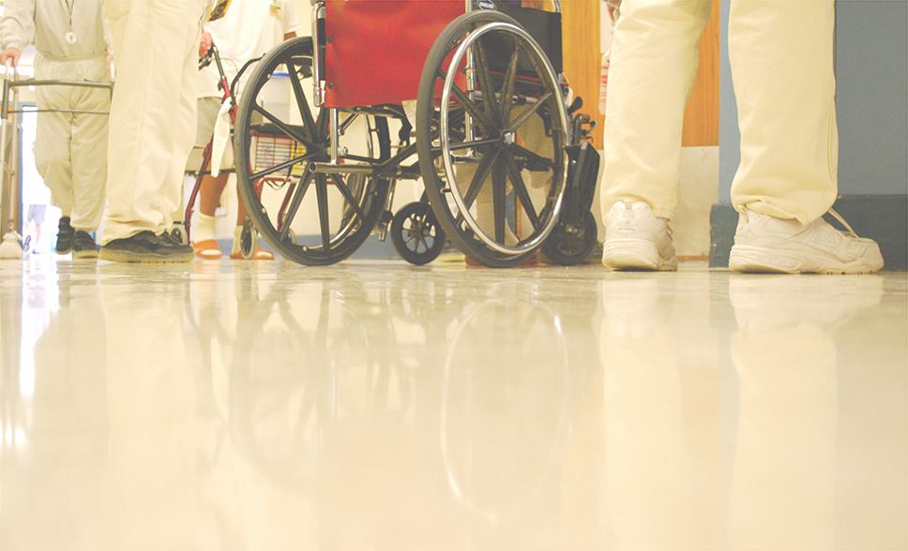

Photo 5 Inmates stand next to another inmate in a wheelchair.

V. RECOMMENDATIONS

A. National Recommendations

- The U.S. Department of Justice should effectively enforce all statutes and regulations necessary to protect the rights of prisoners with disabilities. As set forth in the report above, the violations are flagrant and consistent nationwide, resulting in significant harm to prisoners with disabilities.

- The U.S. Department of Justice should provide guidance about the need to accommodate prisoners with disabilities. Specifically, it should clarify its commitment to enforcement and state that the following or similar administrative structures and activities may assist in ensuring appropriate accommodations.

  - ADA Coordinator
Most prison systems have designated a specific staff person at each facility to respond to requests for accommodations for inmates. These ADA coordinators have the potential to be a valuable resource for inmates with disabilities. They should be trained in the requirements of the ADA, and familiar with the array of accommodations that may be employed in the prison setting.

  - Corrections Ombuds Programs
Though the foregoing case synopses make clear that there are grievance and appeals process in place for inmates to lodge complaints regarding prison conditions and programming, in most states there is no independent entity that may conduct investigations on prison-related claims. Existing processes may lack accessibility for multiple disabilities such as people with low vision or those who are deaf or hard of hearing. Similarly, very few states have administrative bodies that will hear prison-related issues. Thus, once inmates have exhausted the internal grievance system in prison, there is little for them to do but file litigation in state or federal court.

In addition to effective and consistent enforcement at the state and federal level by those entities that have the duty to enforce the law, creating an independent ombuds office would provide for a level of oversight not currently present in most states. This would potentially decrease the number of lawsuits filed by inmates and their advocates by resolving issues at this lower level. P&A agencies already perform similar work by virtue of their Congressional mandate. P&As should be funded to provide this ombuds function.

States with human rights commissions or other administrative bodies that hear claims of discrimination may also consider including prison-related issues within the jurisdiction of those bodies, so that inmate claims regarding disability-based discrimination may be addressed without resorting to full litigation.

  - System-Wide ADA Audit For Programmatic And Physical Accessibility
In light of the numerous cases involving inaccessible bathrooms, showers, and cells, as well as inmate reports regarding the lack of accommodations in prison programming, state departments of corrections should engage a consultant or agency with expertise in ADA compliance to conduct a thorough ADA audit for physical and programmatic accessibility in order to identify areas in need of improvement.

Similarly, each entity should review all of its policies and practices to ensure that they are not creating unnecessary barriers for individuals with disabilities. For example, blanket policies that remove assistive technology devices from prisoners create an unnecessary barrier to those who need them. Prisons may effectively use an individualized determination process that balances prisoner needs with legitimate safety concerns.

Compliance with ADA/Rehab Act and the completion of an internal policy review should be necessary preconditions to the receipt of federal corrections funds.

- Congress should fund a P&A program targeted at assisting individuals with disabilities housed in correctional settings. P&A agencies have a mandate to protect the rights of individuals with disabilities in institutional settings, including, but not limited to, the mandate to investigate allegations of abuse and neglect. P&As provide substantial and increasing levels of representation for inmates with disabilities, housed in a variety of correctional settings.

As this report documents, the reported violations of individual’s rights are significant in number and we surmise that many go unreported due to prison culture and in some cases, labyrinthine and inaccessible complaint procedures. These barriers result in worse conditions for prisoners with disabilities than for other prisoners. P&As solve these problems before they require full litigation; funding for a P&A can improve conditions, reduce recidivism, and conserve public funds.

B. State Recommendations

- P&As across the country should consider increased monitoring and outreach in the prisons in their state. While many P&As are engaging in effective, wide-ranging advocacy related to inmates with disabilities, with increasing numbers of people with disabilities entering the prison system, prisons are quickly becoming the new institutions for people with disabilities. Given the P&As’ decades-long history of advocating on behalf of institutionalized people with disabilities, the P&As are encouraged to employ that expertise in the prison context.

- State prison systems should develop relationships with the state’s P&A. While the prison systems in each state are invariably distinct from one another, those systems that appear most able to respond to and accommodate inmates with disabilities share some common traits. Generally, and not surprisingly, the states with what appear to be the most progressive prison systems often have an ongoing, collaborative relationship with the state P&A. As seen in the foregoing case studies, P&As use a variety of advocacy methods to address disability-related issues in prison and those systems that routinely meet with the state P&A are often able to resolve issues though informal advocacy and negotiation. Obviously not all issues can be resolved this way, and P&As have litigated disability-related issues in the prisons, in both state and federal court. However, on balance it appears that those systems faring the best are those that are collaborators rather than adversaries with the state P&A.

- Law firms and other advocacy groups should partner with P&As to increase capacity to help inmates with disabilities. With the congressional authority to monitor and conduct investigations and advocacy in the correctional setting, many P&As have extensive, first-hand information regarding issues facing inmates with disabilities. Moreover, as demonstrated in some of the foregoing case summaries, P&As have successfully used their agency standing to serve as organizational plaintiffs in prison-related litigation. Other advocacy partners should leverage this advantage by partnering with P&As in assessing and mounting such litigation.

Please visit
AVIDprisonproject.org
for a multimedia version of this report
featuring videos of inmate interviews and more.

ABOUT THE PROJECT
The AVID Prison Project produced this report through a collaboration between The Arizona Center for Disability Law, Disability Law Colorado, The Advocacy Center of Louisiana, Disability Rights New York, Protection and Advocacy for People with Disabilities of South Carolina, Disability Rights Texas, Disability Rights Washington, The National Disability Rights Network, with contributions from other protection and advocacy agencies.

This report, the multimedia report and associated videos,
designed and produced by Rooted in Rights.
Learn more at rootedinrights.org.

Published June 22, 2016
© 2016 Disability Rights Washington

See Jamie Fellner, Human Rights Watch, Old Behind Bars: The Aging Prison Population in the United States 18, 43 (2012), http://www.hrw.org/sites/default/files/reports/usprisons0112webwcover_0.pdf.
See Human Rights Watch, U.S.: Number of Mentally Ill in Prisons Quadrupled (2006), http://www.hrw.org/news/2006/09/05/us-number-mentally-ill-prisons-quadrupled; Doris J. James & Lauren E. Glaze, Bureau of Justice Statistics, U.S. Dep’t of Justice, Special Report: Mental Health Problems of Prison and Jail Inmates 1 (2006), http://www.bjs.gov/content/pub/pdf/mhppji.pdf.
Jennifer Bronson et al., Bureau of Justice Statistics, U.S. Dep’t of Justice, Special Report: Disabilities Among Prison and Jail Inmates, 2011-12 1 (2015), http://www.bjs.gov/content/pub/pdf/dpji1112.pdf.
Paula M. Ditton, Bureau of Justice Statistics, U.S. Dep’t of Justice, Special Report: Mental Health and Treatment of Inmates and Probationers 8 (1999), http://www.bjs.gov/content/pub/pdf/mhtip.pdf .
In a comprehensive report in 2003, Human Rights Watch noted that in some states, inmates with mental illness account for 41 percent of institutional infractions, while constituting only 19 percent of the prison population. Sasha Abramsky & Jamie Fellner, Human Rights Watch, Ill-Equipped: U.S. Prisons and Offenders with Mental Illness 59-60 (2003), http://www.hrw.org/reports/2003/usa1003/usa1003.pdf.
See Bronson et al., supra note 3, at 6.
See Am. Civil Liberties Union, The Dangerous Overuse of Solitary Confinement in the United States 8 (2014), https://www.aclu.org/sites/default/files/assets/stop_solitary_briefing_paper_updated_august_2014.pdf
To fund AVID, DRW applied for cy pres funds that were the result of litigation against AT&T regarding prison phone charges. DRW, along with dozens of other organizations in Washington, was awarded funding from this cy pres pool to conduct corrections-based advocacy. DRW has since obtained additional private grant funding to expand the AVID project to encompass advocacy in specific local Washington jails as well.
While many P&As engage in advocacy relating to conditions in city and county jails, federal correctional facilities, and immigration detention or holding facilities, this report focuses on the work P&As have done in state prisons.
The report includes examples from the following 21 states: Alabama, Arkansas, Colorado, Connecticut, Delaware, Florida, Idaho, Illinois, Iowa, Louisiana, Maine, Minnesota, Mississippi, New Hampshire, New York, Oregon, Pennsylvania, South Carolina, Vermont, Washington, Wisconsin.
See Nat’l Disability Rights Network, Our History, http://www.ndrn.org/about/26-our-history.html (last visited Apr. 29, 2016).
See, e.g., Developmental Disabilities Assistance and Bill of Rights Act of 1975, 42 U.S.C. § 15041-15045; Protection and Advocacy for Individuals with Mental Illnesses Act, 42 U.S.C. § 10801-10851; Protection and Advocacy of Individual Rights, 29 U.S.C. § 794e.
See 42 C.F.R. § 51.42(b).
Given the exhaustion requirements of the Prison Litigation Reform Act, most inmates and advocates begin with advocacy via the prison’s internal grievance system, moving onto other forms of advocacy, particularly litigation, only after exhausting the avenues of redress available within the prison. See 42 U.S.C. § 1997e(a).
See 42 U.S.C. § 10807(a) (requiring that P&As exhaust administrative remedies where appropriate before commencing litigation).
The requirements for an agency asserting organizational standing are set forth in Hunt v. Wash. State Apple Adver. Comm’n, 432 U.S. 333 (1977).
See 42 U.S.C. § 12132; 29 U.S.C. § 794(a); Pa. Dep’t of Corr. v. Yeskey, 524 U.S. 206, 210 (1998) (holding that state-run prisons are “public entities” under Title II of the ADA). Notably, there is some question as to how far the ADA extends to private prisons. While 28 C.F.R. § 35.152(a) states explicitly that the law “applies to public entities that are responsible for the operation or management of adult and juvenile justice jails, detention and correctional facilities, and community correctional facilities, either directly or through contractual, licensing, or other arrangements with public or private entities, in whole or in part, including private correctional facilities,” in the majority of cases that have addressed this issue, the courts have found that a private prison corporation is not in fact a “public entity” or “instrumentality” of the state for the purposes of Title II and, accordingly, not subject to suit under that provision. See, e.g., Phillips v. Tiona, 508 F. App’x 737, 748-54 (10th Cir. 2013) (unpublished) (surveying current case law on the issue and holding that the Corrections Corporation of America, a private, for-profit corporation, was not subject to Title II of the ADA); Edison v. Douberly, 604 F.3d 1307, 1310 (11th Cir. 2010) (finding that defendant employees of a private prison management corporation operating prisons in Florida were not subject to Title II). However, it is possible that inmates held in prisons operated by private corporations could file a Title II claim against their state department of corrections for failing to meet its own obligations under the ADA, despite contracting out for prison services. See Armstrong v. Schwarzenegger, 622 F.3d 1058, 1069 (9th Cir. 2010); 28 C.F.R. § 35.130(b)(1).
Because the protections of the Rehab Act are substantially the same as those afforded under Title II of the ADA, this analysis is focused on the protections afforded by Title II of the ADA. Bragdon v. Abbott, 524 U.S. 624, 632 (1998); 42 U.S.C. § 12201(a).
42 U.S.C. § 12132. A “disability” is further defined under the ADA as “(A) a physical or mental impairment that substantially limits one or more major life activities…; (B) a record of such an impairment; or (C) being regarded as having such an impairment….” 42 U.S.C. § 12102(2)(A)-(C).
42 U.S.C. § 12131(2). In the prison context, the requirement that an individual with a disability meet the “essential eligibility” requirements for a program or service means that inmates with disabilities must be otherwise eligible for the program that they are seeking to engage in. For example, an inmate with a disability may be excluded from a work release program due to the nature of their prior criminal offense. Because such exclusion is based upon non-disability related criteria, it would not run afoul of the ADA.
28 C.F.R. § 35.130(b)(7) (regulation requiring entities to “make reasonable modifications in policies, practices, or procedures when the modifications are necessary to avoid discrimination on the basis of disability, unless the public entity can demonstrate that making the modifications would fundamentally alter the nature of the service, program, or activity.”). See Tennessee v. Lane, 541 U.S. 509, 511-512 (2004) (describing the reasonable modification requirement).
In making such a determination, courts often evaluate the prison practice or policy at issue and its relationship to a legitimate governmental interest, including whether there are alternative means available, the cost of the modification and the administrative burden on the prison in making an accommodation, and the penological interests of the facility. See Turner v. Safley, 482 U.S. 78, 89-91 (1987); Gates v. Rowland, 39 F.3d 1439, 1446-47 (9th Cir. 1994). But see Amos v. Md. Dep’t of Pub. Safety and Corr. Servs., 178 F.3d 212, 220-22 (4th Cir. 1999), vacated on other grounds, 205 F.3d 687 (4th Cir. 2000) (rejecting the strict scrutiny approach taken in Turner and Gates for assessing reasonable accommodations and adopting a more expansive analysis).
28 C.F.R. § 35.152(b)(2).
28 C.F.R. § 35.152(b)(2)(i).
28 C.F.R. § 35.152(b)(2)(ii)-(iii).
28 C.F.R. § 35.152(b)(2)(iv).

